A New Approach to Capital Markets Assumptions Framework and Strategic Asset Allocation for US Life Insurers
Giga Nozadze

Focusing on the Wrong Measure of Risk
Long term allocators like life insurers, pensions, endowments, and sovereign wealth funds operate in different investment worlds. Endowments and SWFs can afford long dated, illiquid bets with alternatives. Life insurers, by contrast, operate under capital rules, manage long dated liabilities, and keep most of their money in fixed income. Their investment is ten or twenty years, so they need capital market assumptions that actually fit that horizon.
This project steps back from the usual toolkit to ask: what do we really need to know about risk and return over the long run? For fixed income, the answer is starting yield adjusted for credit loss, because it consistently explains the bulk of future returns, while private assets are modeled from fundamental economic and financial drivers.
Most importantly, in this paper I argue that, instead of return volatility, the appropriate risk measure to use in this context is the forecast error around long run return assumptions. That distinction matters. Insurers usually hold assets to maturity, so mark to market noise is not as important as in other investment worlds, which leads to my suggested optimal allocations for six US life insurers that are different from their current portfolios:
Current allocations (transparent) are different from optimal weights (solid)
Source: Company 10-K and 10-Q files

Brighthouse
Brighthouse Financial’s liability composition are shaped by its origins as a 2017 spin-off from MetLife, which left it with a mature block of variable annuities (VAs), universal life (UL), and fixed deferred annuity products. These businesses anchor Brighthouse’s liability profile in long-dated, interest-sensitive obligations, with a material share of account value-linked reserves and embedded guarantees. Unlike peers such as Prudential or Corebridge that have substantial group-benefits or pension-risk-transfer exposures, Brighthouse’s liabilities are concentrated in individual retail contracts, resulting in moderate liquidity needs but high duration sensitivity.
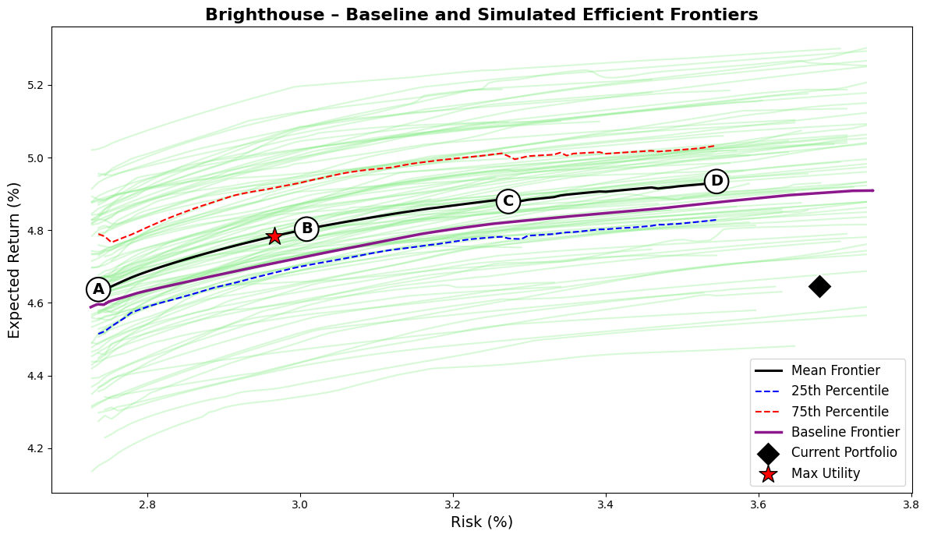
The simplified liability curve I constructed reflects this profile. Approximately 55% of projected liability cash flows fall within the medium-duration bucket (around seven years), corresponding to deferred annuity runoff and policyholder withdrawals; 30% occupy the short-duration bucket (typically surrenders and near-term crediting obligations); and 15% extend into the long bucket (payout annuities and universal life). This produces an average liability duration of roughly 7.8 years.
Brighthouse’s general account reflects a conservative, income-focused approach typical of mature, retail-oriented life insurers. As of June 2025, the portfolio is led by public investment-grade corporates (40%), with meaningful allocations to private credit (26%), structured securities (19%), and Treasuries (10%). Alternatives are limited, with only 4% in private equity and real estate. This supports an average credit rating of AA minus, a duration of 6.2 years, and a modest negative duration gap of 1.6 years, typical for insurers managing call-sensitive variable annuity liabilities. Capital usage is low at 1.9 percent, reflecting a focus on high-quality, capital-efficient assets.
Despite this disciplined setup, the portfolio falls short of efficiency. Relative to the robust efficient frontier, its current mix delivers a 4.65% expected return with 3.68% volatility, well inside the baseline and mean frontiers. At the same risk, expected return could be boosted by 15 to 30 basis points, or risk reduced by 60 to 90 basis points with no return sacrifice. The maximum-surplus portfolio at λ = 8 delivers 4.70% return at 2.95% volatility, lifting the Sharpe ratio from 0.18 to 0.24. Crucially, this gain is achieved without raising capital use or degrading credit quality (in fact the required risk-based capital is more than halved from 1.92% to 0.74%).
Metric/Asset | Current | Port A | Port B | Port C | Port D | Max Utility
Expected Return (%) | 4.65 | 4.59 | 4.72 | 4.80 | 4.84 | 4.70
Risk (%) | 3.68 | 2.74 | 3.00 | 3.25 | 3.49 | 2.95
Sharpe Ratio | 0.18 | 0.22 | 0.24 | 0.25 | 0.24 | 0.24
Avg FI Credit Rating | AA- | AA- | AA- | AA- | AA- | AA-
FI Duration (years) | 6.20 | 6.35 | 6.34 | 6.35 | 6.35 | 6.34
Net Duration (years) | 0.84 | 0.99 | 0.99 | 1.00 | 1.00 | 0.99
Capital Use (%) | 1.92 | 0.60 | 0.76 | 0.83 | 0.85 | 0.74
US Treasuries, Short/Intermediate | 3.7 | 9.9 | 6.7 | 6.1 | 4.8 | 6.7
US Treasuries, Long | 2.6 | 0.0 | 0.3 | 1.1 | 1.9 | 0.2
US Taxable Munis | 3.3 | 1.2 | 0.0 | 0.0 | 0.0 | 0.0
Global ex-US Government, hedged | 0.9 | 0.0 | 0.0 | 0.0 | 0.0 | 0.0
US Public Corporates IG AAA | 3.2 | 10.0 | 10.0 | 9.7 | 9.3 | 10.0
US Public Corporates IG AA | 6.4 | 9.9 | 6.5 | 5.4 | 3.9 | 7.0
US Public Corporates IG A | 9.6 | 9.7 | 9.3 | 9.4 | 9.1 | 9.2
US Public Corporates IG BBB | 9.2 | 0.1 | 1.8 | 2.3 | 2.4 | 1.8
US Public Corporates, HY Intermediate | 0.5 | 0.0 | 0.8 | 1.1 | 1.2 | 0.7
US Public Corporates, HY Long | 0.3 | 0.0 | 2.1 | 3.2 | 3.3 | 1.7
Global ex-US Corporates, hedged | 11.1 | 10.0 | 7.4 | 2.4 | 0.6 | 8.0
Residential Mortgage-Backed Securities | 7.4 | 8.4 | 10.0 | 10.0 | 10.0 | 10.0
Commercial Mortgage-Backed Securities | 5.8 | 9.8 | 9.4 | 9.6 | 9.3 | 9.4
Asset-Backed Securities (ABS) | 5.4 | 0.6 | 4.7 | 7.0 | 7.1 | 4.3
Corporate IG Private Placement A | 4.1 | 10.0 | 10.0 | 10.0 | 10.0 | 10.0
Corporate IG Private Placement BBB | 2.0 | 10.0 | 10.0 | 10.0 | 10.0 | 10.0
Corporate HY Private (Leveraged Loans) | 0.2 | 0.1 | 0.6 | 0.4 | 0.4 | 0.6
Residential Mortgage Whole Loans | 6.7 | 10.0 | 10.0 | 10.0 | 10.0 | 10.0
Commercial Mortgage Whole Loans | 13.4 | 0.0 | 0.4 | 2.3 | 6.7 | 0.3
Private Equity | 3.6 | 0.2 | 0.0 | 0.1 | 0.0 | 0.0
Real Estate (via partnerships, equity) | 0.6 | 0.0 | 0.0 | 0.0 | 0.0 | 0.0
The model consistently tilts toward private placements, RMBS, CMBS, and mortgage whole loans, each approaching their 10% caps. These assets offer the strongest return-to-RBC tradeoffs (private credit due to high yield pickup and structured securities for their prime ratings and therefore low RBC costs because they are agency mortgages). Exposure to commercial mortgage whole loans is trimmed, due to weaker capital treatment and borrower concentration. The optimizer also reduces weight in global corporates and short Treasuries, reallocating toward domestic spread assets with better capital efficiency. High yield and private equity remain minimal, below 4 percent, as their capital charges outweigh return benefits. Overall credit quality stays stable around A plus to AA minus, while portfolio duration increases slightly to 6.8 to 7.1 years. Capital use declines to near 1.0%.
The detailed methodology is given later in the paper. The analysis of 5 other life insurers is given in the appendix. It should be noted that the current allocations might be the result of different objective functions these companies have, and I am making assumptions based on their respective general business models, probable liability structures through my rather simplistic liability modeling, and the consistent set of constraints they face.

Mean Reversion and Time Diversification
Returns are not random draws from a hat each year. They are linked over time, hence serial correlation (SC). Positive SC means strength tends to follow strength, called short term momentum, while negative SC means weak periods tend to be followed by stronger ones, called mean reversion. Time diversification shows up when there is enough mean reversion, and when that self-correction is present, the average outcome over many years becomes more stable than a single year volatility snapshot suggests.
A simple way to see this is to compare two measures, namely standard deviation (traditional vol) and standard deviation of average return CAGRs (kind of like standard error) scaled by square root of horizon (to put them on the same footing).
First is the standard deviation of one year returns. This is the usual volatility statistic that captures mark to market movement. It is helpful for a sense of noise, but it overstates uncertainty for a hold to maturity investor because a weak year can be followed by stronger years and income keeps compounding.
$R_{t,1\text{y}}=\frac{I_{t+1}}{I_{t}}-1$ $σ_{1\text{y}}= {stdev}_{t}(R_{t,1\text{y}})$
Second is the dispersion of ten year compounded returns (CAGRs), which is like standard error (standard deviation of average returns). To get this, I build many overlapping ten year (assumed investment horizon) windows through history and compute the compounded annual growth rate in each window. Then look at how those CAGRs are spread out and scale it by square root of 10 to put it on the same footing as standard deviation itself.
${CAGR}_{10}(t) = [\frac{I(t+10)}{I(t)}]^{1/10}-1$ $σ_{\text{ann}}(10) = \sqrt{10} {stdev}_{t}({CAGR}_{10}(t))$
If yearly returns were completely independent and had the same volatility, the standard deviation of the 10 year average (CAGR) would shrink with the square root of 10, and after the scaling described above we would end up right back at the one year volatility. In real bond markets years are not independent. Mean reversion in spreads and the pull of income make weak periods more likely to be followed by stronger ones. That negative linkage tightens the distribution of long horizon outcomes even after scaling. If momentum dominated instead, the distribution would not tighten and could even widen.
What’s more, for certain types of asset classes such as HY, hybrids, preferreds, and REITs, the longer the horizon, the lower the standard deviation of CAGRs (scaled), which points to the very fact that due to mean reversion, the volatility of 1-year returns overstates the true risk over the long run.
To see this, I take every start month for time series of indices, compute the compounded return to a fixed future date (after T years), and convert each one to an annual rate. That number is the T year CAGR for that start month. Across all start months this gives a distribution of T year CAGRs. The standard deviation of that distribution tells how uncertain the long run average outcome is at horizon T. Since CAGRs are averages across T years and are naturally less noisy than one year returns (like standard error (stdev of average) vs standard deviation itself), I multiply the standard deviation of the T year CAGRs by the square root of T, to put all horizons on the same annual footing.

Time diversification effect is most pronounced in HY securities
As mentioned above, high yield shows strong time diversification, because credit spreads tend to overshoot during stress and then grind back as defaults peak and recoveries come through, which is also, mildly but still, pronounced in investment grade securities. That pattern is reliable over business cycles. Structured indexes improve a little, while Treasuries move the other way, which is consistent with long swings in real yields and inflation that do not quickly mean revert.
Enter Starting Yield
Life insurers mostly hold bonds to maturity and book them at amortized cost. Over a ten year horizon, the thing that drives results is the cash yield collected, adjusted for credit losses. Day to day price swings matter far less. For that reason the natural forecast for a ten year compounded return is simply the starting yield minus expected credit loss (ECL).
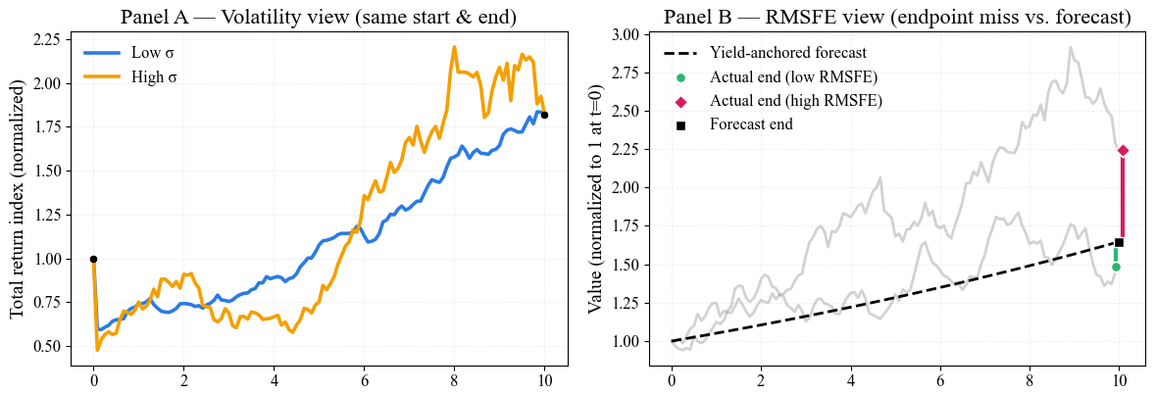
The charts above show this difference. In panel A, the difference between two time series is their variance, with the same starting and ending points, while panel B emphasizes the difference between ending points, which, as I argue here, should be the focus and the risk measure used in portfolio optimization analytics for long-term allocators.
Each scatter below compares the starting yield on the x axis (not adjusted for ECL) with the realized ten year return (CAGR) on the y axis. The relationship is tight for the given indexes as well as ones not shown here. Slopes are close to one and R squared values are high, which means that over decade horizons the entry yield explains most of what ultimately happens.
Starting yield is a good indicators of actual returns
With returns anchored, the next step is to define risk in a way that matches how insurers actually experience it. Here risk means how far the realized ten year outcome can end up from the forecast that comes from the entry yield, not how bouncy prices are month to month.
Third and, in my opinion, the most useful measure of risk is the root mean square error around a very simple forecast (starting yield). For every start date, I take the forecast ten year CAGR (starting yield) and compare it with the realized ten year CAGR. The difference is the forecast error. Then I square these errors, average them, and take the square root. That is Root Mean Squared Forecast Error (RMSFE), which I then multiply by the square root of 10 again to put it on the same footing as standard deviation. Basically, I’m doing the same as above where I computed standard deviation of average returns (CAGRs) and scaled it by the square root of 10, but here, instead of deducting the mean of average returns in the formula (volatility formula), I deduct actual starting yields, because I argue that they contain useful information, which effectively decreases the long-term risk and uncertainty the asset allocators actually experience (and should care about). In plain words, RMSFE is the typical miss of the yield based forecast. It bundles the two uncertainties a buy and hold bond investor really faces over time, which are reinvestment risk and credit loss risk. Because RMSFE is an error on a ten year average, I report it on an annual scale by
${Forecast}_{10}(t) = Y_{\text{start}}(t)$ $ε(t) = {CAGR}_{10}(t) - {Forecast}_{10}(t)$
$${RMSFE}_{\text{ann}}(10) = \sqrt{ {avg}_{t}[ε(t)^{2}] } × \sqrt{10}$$

Lower deviation in CAGRs compared to annual returns suggest mean reversion in returns, mainly driven by HY bonds, hybrids, and long-term indexes, with even lower RMSFE measure
$$σ_{\text{ann}}\left(10\right) = \sqrt{10} σ_{CAGR}\left(10\right)$$
$$σ_{1\text{y}}= {stdev}_{t}\left(R_{t,1\text{y}}\right)$$
$${RMSFE}_{\text{ann}}\left(10\right) = \sqrt{ {avg}_{t}[ε(t)]} × \sqrt{10}$$
The second (blue) bar demonstrates mean reversion: the distribution of multi-year CAGRs has a noticeably lower volatility (mean and median) than 1-year returns. Intuitively, extreme short-term shocks (e.g., a sudden yield spike) wash out over longer horizons as bonds gravitate back toward par and reinvestment rates stabilize. Statistically, the standard deviation of CAGRs shrinks relative to 1-year volatility because past deviations are gradually reversed, i.e., mean reversion at work.
In the textbook model, returns are independent and identically distributed (i.i.d.). Under i.i.d., the volatility of an average annual return over $T$years declines by the square-root-of-time rule, i.e. $σ_{T\text{Y,avg}}=σ_{1\text{Y}}/\sqrt{T}$. This underpins results like Samuelson’s Invariance Theorem (optimal allocation independent of horizon). But square-root-of-time i.i.d. scaling overstates strategic-horizon uncertainty, whereas RMSFE is a better proxy for the risk of missing long-term targets. Practically, risk should be defined as the uncertainty of hitting the plan, not year-to-year noise, which can justify allocations that look “aggressive” under traditional σ metrics. The key distinction is conditional vs. unconditional: the stdev of 10-year CAGRs is an unconditional spread around a sample average, while RMSFE compares each start date’s realized 10-year CAGR to the plan we could have made then (starting yield), bundling reinvestment and credit-loss risk and filtering out variation already explained by the known entry yield.
Viewed through this horizon lens, high-yield, hybrids, and long-duration assets often dismissed as “too volatile”, look attractive for strategic allocations because their returns stabilize over time as spreads mean-revert and coupons compound. Finally, I combine horizon uncertainty with near-term noise:
$$\boxed{ σ = 0.7 {RMSFE}_{\text{ann}} + 0.3 σ_{1\text{Y}} }$$
The 70% weight reflects long-term target risk (meeting the decade plan). The 30% weight preserves a practical allowance for capital/liquidity constraints and life insurers’ relatively lower tolerance for short term drawdowns compared to endowments and wealth funds.

Private Equity
y_{u} | g_{u} | r_{u} = y_{u} + g_{u} | D/E | k_{d} | r_{l} = r_{u} + (D/E)*(r_{u} - k_{d}) | m | r_{g} = r_{l} + m | f | r_{r} = r_{g} - f | i | r = r_{r} + i
Income Yield | Real Growth Rate | Real Unlevered Return | Debt to Equity | Real Cost of Debt | Real levered Return | Multiple Expansion | Gross Real Expected Return | Fees | Net Expected Real Return | Expected Inflation | Net Expected Return
3.6% | + 3.0% | = 6.6% | 52.0% | 3.1% | 8.4% | + 0.3% | = 8.7% | -4.0% | = 4.7% | + 2.3% | = 7.0%
Income Yield – I collected data on recent private equity transactions from Bloomberg and focused on last-twelve-month deal multiples. Since direct earnings yields weren’t available, I used transaction value to EBIT (TV/EBIT) ratios as a proxy. For most deals, these figures weren’t automatically downloadable, so I retrieved them manually for around 200 companies. I then averaged the inverse of these ratios to estimate an income yield for PE, which came out to about 3.6%.
Growth Rate – To capture the real growth potential of PE portfolios, I assumed an unlevered real growth rate of 3.0%, which is about twice as high as the same metric for public markets (Russell 2000 estimated EPS growth rate). The reasoning is that private equity managers can add value through operational improvements, margin expansion, and concentration in higher-growth sectors.
Leverage – I applied a debt-to-equity ratio of 52%, interpolated from post-2008 LBO data and reflecting today’s more conservative financing because of high cost of debt. Leveraging the unlevered return (6.6%) with this D/E and a real cost of debt of 3.1% raises the real levered equity return to about 8.4%. The logic is standard corporate finance: equity holders benefit from borrowing so long as operating returns exceed the interest cost.
Real Cost of Debt – I estimate the real cost of debt as real cash rate (nominal SOFR-expected inflation) + one-third of the HY OAS, averaged over the last year to match how I average purchase multiples. The logic is: most LBO debt is floating-rate secured bank debt; a practical proxy for its spread is about two-thirds of the HY OAS, but issuers don’t effectively pay the full stated spread once we account for default losses borne by lenders. So I haircut the spread by half, which leaves ~one-third of HY OAS added to real LIBOR. I also ignore the interest tax shield (jurisdictions vary), which biases k_{d} slightly up, but that’s offset by the conservative haircut I already apply to the spread.
Multiple Expansion – I added a conservative adjustment of +0.3% for multiple expansion. This reflects the possibility that PE managers, through active ownership and timing of exits, can sell companies at somewhat higher valuation multiples than entry. I floor this component at zero, consistent with AQR’s skeptical stance, and only allow for a small partial convergence toward public market multiples.
Fees – I subtracted 4.0% to reflect management and performance fees. This haircut is somewhat below AQR’s 5.7% historical average, since I expect net performance fees to be lower going forward as returns compress. Even so, the fee drag remains the single largest deduction in the framework.
Inflation Adjustment – Finally, I added back expected inflation of 2.3% to convert from real to nominal returns, yielding a net nominal expected return of roughly 7.0%.
I view the expected return profile of private equity relative to public markets through the lens of factor exposures. Buyout strategies, which dominate the private equity universe, systematically load more heavily on certain risks than public equities. Because leverage is central to the buyout model, PE portfolios effectively run at higher equity betas, closer to 1.2–1.5 in practice rather than the sub-1.0 estimates implied by smoothed NAVs. This means the true risk is higher than what reported returns suggest, and that risk tends to show up in prolonged bear markets rather than in short, sharp drawdowns.
The illiquidity angle is more nuanced. In theory, locking capital for 5–10 years should command a premium, but in practice, much of it is competed away. Many investors seem content to trade off some economic compensation in exchange for smoother reported returns and the reduced headline volatility that comes with appraisal-based valuations. As a result, the realized illiquidity premium often looks small or even nonexistent.
The industry track record also points to little evidence of persistent net alpha. Several large-sample studies find that, once we control for leverage, small-cap exposure, and fees, private equity returns are largely explained by traditional risk factors. In other words, the outperformance often attributed to manager skill or illiquidity premia is better understood as compensation for bearing higher equity beta and structural tilts. Fees in particular eat up much of the gross excess return, making it difficult to justify a positive “alpha” at the asset-class level.
Beyond leverage, private equity tends to tilt toward smaller and historically cheaper companies. The small-cap bias is visible in the typical characteristics of buyout targets, while the value bias has become less consistent in recent years as entry multiples have risen. Taking these exposures together, I think it is most realistic to treat private equity as a leveraged small-cap equity exposure, with higher sensitivity to the equity risk premium, some residual size tilt, and no persistent net alpha after fees.
For my expected return modeling, I primarily use a discounted cash-flow framework similar to AQR’s yield-based approach: I start from an estimate of the unlevered return (income yield plus real growth), then add the effects of financial leverage, conservatively account for potential multiple expansion, and subtract fees. This makes the drivers of PE returns more transparent and allows me to stress-test assumptions around valuations, leverage costs, and growth. That said, I also supplement this analysis with a simpler public-equity-based comparison, where I treat private equity as a leveraged small-cap exposure with no net alpha. Using this as a cross-check provides an additional perspective and helps ensure that my forward-looking assumptions remain grounded against public market benchmarks.
In constructing my CMA inputs, I use arithmetic mean expected returns rather than geometric, since arithmetic returns are the appropriate measure for portfolio optimization and strategic asset allocation, they represent the expectation of a one-period return and avoid deducting variance drag, which the optimizer already accounts for through the volatility input. Reported geometric means, while more intuitive for compounding, understate the inputs required for allocation modeling. For the cash or risk-free rate, I do not rely on today’s short-term SOFR or T-bill yield, which are cyclical and unsuitable for a strategic horizon. Instead, I assume a long-run real cash rate (anchored by historical averages and central bank estimates of the neutral rate) combined with long-term inflation expectations from breakeven markets, ensuring consistency with a 10-year investment horizon.

Real Estate
NOI Yield | CapEx (~NOI/3) | Cashflow Yield | Real Growth | Unlevered Real Expected Return | Expected Inflation | Unlevered Nominal Expected Return
4.7% | - 1.6% | = 3.1% | + 0.0% | = 3.1% | + 2.3% | = 5.4%
NOI Yield – I begin with the net operating income yield, which reflects rental income as a percentage of property market value. This is the steady income stream that properties generate before accounting for maintenance costs. It is analogous to a gross yield, similar in spirit to a dividend yield in equities but based on property-level cashflows.
CapEx Deduction – From NOI, I subtract recurring capital expenditures. These are the costs required to maintain and preserve the property’s income-generating capacity. Empirical work (e.g., Pagliari 2017) shows that these expenditures typically average about one-third of NOI. In my case, that adjustment reduces the yield by 1.56%.
Cashflow Yield – The result is the free cashflow yield, representing the actual income available to investors after maintaining the property. This measure is more relevant than raw NOI because it accounts for the fact that real estate is capital-intensive and requires continual upkeep. At this stage, my unlevered real cashflow yield is 3.13%.
Real Growth – For growth assumptions, I use a conservative real growth rate of zero. While rents may rise with GDP or demographics, long-term evidence suggests that real estate income growth has often barely kept up with inflation, or, in some cases, underperformed it. This assumption is consistent with AQR’s treatment of private real estate, where the long-run real growth contribution is taken as negligible.
Unlevered Real Expected Return – By combining the free cashflow yield and the real growth assumption, I arrive at an unlevered real expected return of 3.13%. This reflects the baseline compensation investors can expect before inflation and leverage, directly from property-level economics.
Inflation – To convert to nominal terms, I add expected inflation. Here, I assume 2.28%, which captures the anticipated erosion of purchasing power over time. This step aligns real estate projections with nominal return frameworks used in portfolio construction.
Unlevered Nominal Expected Return – Finally, adding inflation to the unlevered real expected return yields a nominal expected return of 5.41%. This is the figure I use for strategic asset allocation purposes, providing a consistent basis of comparison with public equities and fixed income.

Correlations and Variance/Covariance
I build the variance-covariance matrix from the risk measures I discussed above, which are weighted average of RMSFE (long-term uncertainty) and traditional standard deviation, which for public fixed income comes from excess-return distributions. For private equity, I use a yield-based build (income yield + growth - fees, adjusted for leverage) and a public proxy, levered Russell 2000 excess returns to reflect buyout beta. For private real estate, I pair a cash-flow model (NOI - CapEx + inflation) with a listed REIT proxy for volatility and co-movement, since appraisal series are too smooth. To capture co-movement, I form monthly excess-return proxies for each sleeve and estimate the correlation matrix empirically. I then combine these correlations with my custom risks via the standard identity:
$${Cov}_{i,j}=ρ_{i,j}*σ_{i}*σ_{j}$$
This produces a covariance matrix whose off-diagonals reflect realistic market correlations, while the diagonals embed the long-term, economics-based risk I believe matters for strategic allocation across public markets, private equity, and private real estate.
The full correlation matrix is given in the appendix.

 | Asset | Schdl. | Rating | NAIC | Capital Charge | Mat. (year) | Dur. (year) | Starting Yield | ECL | Expected Return | ER (Cap-Adjusted) | StDev | Long-term Uncertainty | WA Risk
Government | US Treasuries, Short/Intermediate | D-1 | AAA | 1A | 0.00% | 4.0 | 3.7 | 3.83% | 0.00% | 3.83% | 3.83% | 6.01% | 2.93% | 3.86%
Government | US Treasuries, Long | D-1 | AAA | 1A | 0.00% | 22.1 | 13.8 | 4.80% | 0.00% | 4.80% | 4.80% | 13.57% | 6.36% | 8.52%
Government | US Taxable Munis | D-1 | AA | 1C | 0.00% | 13.3 | 10.6 | 3.96% | 0.10% | 3.86% | 3.86% | 8.21% | 2.41% | 4.15%
Government | Global ex-US Government, hedged | D-1 | AA | 1C | 0.42% | 9.7 | 8.3 | 3.07% | 0.10% | 2.97% | 2.80% | 3.99% | 4.24% | 4.17%
Public Corporates | US Public Corporates IG AAA | D-1 | AAA | 1A | 0.16% | 5.4 | 5.0 | 4.23% | 0.00% | 4.23% | 4.16% | 4.45% | 2.29% | 2.94%
Public Corporates | US Public Corporates IG AA | D-1 | AA | 1C | 0.42% | 7.8 | 6.8 | 4.36% | 0.10% | 4.26% | 4.09% | 5.48% | 2.45% | 3.36%
Public Corporates | US Public Corporates IG A | D-1 | A | 1F | 0.82% | 10.3 | 8.3 | 4.87% | 0.07% | 4.80% | 4.48% | 6.27% | 2.82% | 3.85%
Public Corporates | US Public Corporates IG BBB | D-1 | BBB | 2B | 1.52% | 10.5 | 8.2 | 5.21% | 0.49% | 4.72% | 4.11% | 7.23% | 3.20% | 4.41%
Public Corporates | US Public Corporates, HY Intermediate | D-1 | BB– | 3C | 6.02% | 4.5 | 3.9 | 7.04% | 0.67% | 6.37% | 3.96% | 12.46% | 12.80% | 12.70%
Public Corporates | US Public Corporates, HY Long | D-1 | BB– | 3C | 6.02% | 16.3 | 9.5 | 7.87% | 0.67% | 7.20% | 4.79% | 18.04% | 8.94% | 11.67%
Public Corporates | Global ex-US Corporates, hedged | D-1 | A | 1F | 0.82% | 7.0 | 6.2 | 3.92% | 0.07% | 3.85% | 3.52% | 5.99% | 1.12% | 2.58%
Structured | Residential Mortgage-Backed Securities | D-1 | AA | 1C | 0.00% | 7.8 | 6.7 | 4.93% | 0.10% | 4.83% | 4.83% | 8.15% | 3.09% | 4.61%
Structured | Commercial Mortgage-Backed Securities | D-1 | AA | 1C | 0.00% | 4.4 | 4.1 | 4.69% | 0.10% | 4.59% | 4.59% | 7.74% | 3.69% | 4.90%
Structured | Asset-Backed Securities | D-1 | AA | 1C | 0.42% | 3.6 | 3.3 | 4.41% | 0.10% | 4.31% | 4.14% | 5.82% | 5.49% | 5.59%
Private Credit | Corporate IG Private Placement A | D-1 | A | 1F | 0.82% | 10.3 | 8.1 | 5.52% | 0.07% | 5.45% | 5.13% | 5.34% | 2.78% | 3.55%
Private Credit | Corporate IG Private Placement BBB | D-1 | BBB | 2B | 1.52% | 10.5 | 8.0 | 5.84% | 0.49% | 5.35% | 4.75% | 5.70% | 3.20% | 3.95%
Private Credit | Corporate HY Private (Leveraged Loans) | D-1 | B+ | 4A | 7.39% | 4.7 | 3.9 | 7.99% | 2.42% | 5.57% | 2.62% | 14.43% | 8.94% | 10.58%
Private Credit | Residential Mortgage Whole Loans | B | AA | 1C | 0.68% | 7.7 | 6.4 | 4.90% | 0.10% | 4.80% | 4.52% | 2.86% | 3.09% | 3.02%
Private Credit | Commercial Mortgage Whole Loans | B | AAA | 1A | 0.90% | 4.4 | 4.1 | 4.76% | 0.00% | 4.76% | 4.40% | 13.15% | 6.62% | 8.58%
Illiqu. | Private Equity | BA | - | - | 30.00% | - | - | 6.98% |  | 6.98% | 3.98% | - | - | 25.27%
Illiqu. | Real Estate (via partnerships, equity) | BA | - | - | 30.00% | - | - | 5.40% |  | 5.40% | 2.40% | - | - | 17.5%

Optimization
Objective
To analyze and compare the strategic positioning of U.S. life insurers, I developed a robust surplus optimization framework designed to simulate forward-looking efficient frontiers under parameter uncertainty, regulatory capital frictions, and liability-aware portfolio constraints. The model aims to evaluate how each insurer’s existing general account allocation compares to the theoretically optimal mix given the same investment opportunity set, liability duration profile, and regulatory capital environment. At the core of the framework is a surplus-based objective function, which maximizes the expected return on assets net of both surplus volatility and capital consumption:
$$\underset{w}{max⁡} μ^{⊤}w - λ(w^{⊤}Σw) - ϕ(c^{⊤}w)$$where $w$represents portfolio weights, $μ$is the vector of expected returns, $Σ$is the covariance matrix of asset returns, and $c$is a vector of capital charges approximating NAIC risk-based capital (RBC) factors. The parameter $λ$captures risk aversion to surplus volatility, while $ϕ$penalizes capital-intensive allocations.
Constraints
The optimizer embeds several layers of realistic institutional constraints that reflect both regulatory and portfolio management practices of life insurers:
- $\sum{w_{i}}=1$, with individual asset weights bounded between 0% and 10% to prevent excessive concentration.
- The portfolio’s duration must remain within ±1 year of the company’s liability duration estimate. When KRD matching is active, bucket exposures must stay within ±30% of liability weights in the 5-year, 10-year, and 20-year key-rate zones.
- Average fixed-income credit quality must remain at or above A+. Exposure to BBB-rated assets is capped at 15%, and exposure below investment grade is capped at 5%. These limits ensure credit discipline consistent with regulatory and internal policy guidelines.
- The model introduces granular constraints to reflect insurer investment policies:
  - Private equity ≤ 5%
  - Leveraged loans ≤ 5%
  - Global ex-US corporates ≤ 10%
  - Real estate equity ≤ 5%
  - Commercial and residential mortgage whole loans ≤ 20% combined
  - Direct lending / private credit ≤ 20%
  - All alternative and strategic assets combined ≤ 35%
Liabilities
A key differentiator of the framework is its explicit integration of liability profiles for each insurer. Rather than treating liabilities as a single duration target, I model them as weighted exponential-decay cash flow curves with three maturity buckets, Short, Medium, and Long, parameterized by both weight and characteristic duration. The parameters are customized for each insurer to reflect its business mix. For example, companies with large variable annuity (VA) or retirement exposures are modeled with higher weight in the “Medium” bucket, while those with greater guaranteed or payout annuity exposure have more weight in “Long” liabilities. The liability cash flow weights $L_{t}$ are generated as:
$$L_{t}∝\sum_{b}{w_{b}e^{-\frac{t}{D_{b}}}}$$
where $w_{b }$and $D_{b}$denote the weight and average duration of bucket $b$. The curve is normalized so that $\sum{L_{t}}=1$.
Each company’s average Macaulay-like liability duration is computed from this curve and serves as a duration-matching constraint in the optimization. The framework can also optionally activate Key-Rate Duration (KRD) matching, which constrains portfolio exposure in coarse maturity buckets (e.g., 0–7, 7–12, and 12–40 years) to match the liability term structure within a tolerance band (typically ±30%). This design links asset allocation directly to the liability profile, allowing the optimizer to operate in surplus space rather than total return space, capturing the insurer’s true economic objective.
Robust Scenario Simulation
To address estimation uncertainty in expected returns and correlations, the framework incorporates a Monte Carlo resampling procedure that generates 100 independent capital market scenarios for each insurer. In each scenario:
- Expected returns ($μ$) are perturbed with both a common market forecast error and an idiosyncratic component, scaled to 4% and 5% of the median asset volatility, respectively.
- Volatilities are jittered by ±2%, and correlations are perturbed by ±1 percentage point, with the resulting matrices projected back to the nearest positive semi-definite correlation structure.
- Each simulated covariance matrix is then shrunk 40% toward the base matrix for numerical stability.
This produces 100 feasible $(μ_{s},Σ_{s})$pairs per insurer, from which I solve the optimization across 60-80 risk-aversion levels ($λ$ grid) to trace each scenario’s efficient frontier. All frontiers are interpolated to a common volatility grid, and only points with at least 80% scenario coverage are retained. The resulting mean, interquartile curves form the robust frontier envelope, representing the range of plausible efficiency outcomes under forecast uncertainty.
Modeling Assumptions and Limitations
It is important to note that some elements of this framework are stylized representations rather than direct empirical observations. Since insurer liability structures are not publicly disclosed in detail, I approximate each firm’s liability term structure using informed assumptions based on its business mix, product composition, and reported average asset durations. Similarly, the constraints used in the optimization reflect typical U.S. life insurer investment policies and RBC considerations, not necessarily the exact internal limits of the firms studied. Finally, while the optimization framework is designed to reflect the economic objectives and balance-sheet logic of life insurers, preserving surplus stability, maximizing capital-adjusted yield, and maintaining liability alignment, it does not claim to reproduce the exact optimization algorithms or governance processes used by these institutions. Rather, the model serves as a conceptual and quantitative approximation of how a rational, surplus-focused life insurer would behave under the same market conditions and regulatory environment.

Factor Analysis and Asset/Liability Simulation
This stage extends the analysis beyond static optimization to evaluate how portfolios perform under changing economic and market conditions. The goal is to connect each asset’s risk and return characteristics to common systematic drivers, simulate their joint evolution with liabilities, and assess long-term surplus outcomes.
First I estimate a multi-factor framework using monthly historical data on macro-financial variables and asset excess returns. Each asset was regressed on four standardized factors:
- changes in the risk-free rate level (ΔL)
- changes in the yield-curve slope (ΔS)
- changes in investment-grade credit spreads (SprIG)
- equity market excess returns (E).
These factors capture the main channels through which macro conditions affect insurers’ portfolios, interest rate shifts, curve movements, credit spread behavior, and equity risk sensitivity.
Multicollinearity diagnostics ensured factor stability before estimation. Ordinary least squares regressions with Newey-West (HAC) standard errors were then used to correct for serial correlation in monthly returns. Only statistically significant coefficients (p < 0.10) were retained, ensuring that the estimated betas reflect robust and economically meaningful relationships. Residual standard deviations were stored as idiosyncratic volatilities to be used in the simulation stage.
To account for changing macro-financial environments, factor covariances were estimated separately for two regimes defined by the 36-month rolling correlation between ΔL and E. Periods with positive correlation were classified as normal (typical disinflationary conditions), while periods with negative correlation were classified as inflationary (stock-bond co-movement). This captures how diversification benefits vary across market states, a key consideration for insurers exposed to both rate and credit risk.
Expected asset returns from the optimization stage were combined with the estimated betas and regime-dependent covariances to form the stochastic simulation model. Asset returns were generated according to:
$$r_{asset}=μ+β^{'}F+ε$$
where $μ$is the expected monthly return, $β$is the vector of significant factor loadings, $F$represents factor shocks drawn from regime-specific covariance matrices, and $ε$is the idiosyncratic noise term.
Liability returns were modeled as a function of accrual rate and sensitivity to rate level and slope changes:
$$r_{liability}=accrual+β_{AL}⋅ΔL+β_{dS}⋅ΔS$$
Liability parameters were company-specific, derived from each firm’s duration and liquidity profile. This ensures that asset and liability movements are internally consistent within each simulation path.
The model simulated asset and liability values jointly over 10,000 Monte Carlo paths and a 10-year horizon (120 months). Each simulation randomly transitioned between normal and inflationary regimes based on their historical probabilities, producing realistic distributions of asset, liability, and surplus outcomes. Three metrics summarize the results:
- H1 (surplus growth): Median surplus compound annual growth rate (CAGR) over the 10-year horizon
- H2 (shortfall risk): Probability that surplus becomes negative, and probability that surplus CAGR falls below the liability discount rate
- H3 (RBC efficiency): Median surplus CAGR per unit of regulatory capital, measuring surplus generated per unit of required capital
Results across all six insurers show consistent patterns. RMSFE-based (robust) optimized portfolios achieve higher surplus growth, lower shortfall risk, and greater RBC efficiency compared with volatility-minimizing portfolios. Improvements in surplus CAGR averaged 10-13 basis points, shortfall probabilities declined by about 2 percentage points, and surplus per unit of capital increased by roughly 0.15-0.20.
Company | Δ Surplus CAGR (RMSFE–VOL) | Δ P(Surplus<0) | Δ Surplus/RBC
Brighthouse | +0.10% | −2.3 pp | +0.13
Corebridge | +0.12% | −2.3 pp | +0.17
MetLife | +0.10% | −1.5 pp | +0.17
Principal | +0.13% | −2.2 pp | +0.16
Prudential | +0.11% | −1.9 pp | +0.15
Voya | +0.11% | −1.6 pp | +0.19
The observed improvement in surplus efficiency stems from the way the RMSFE-based risk measure captures long-term uncertainty alongside short-term volatility. While both approaches use the same optimization framework and constraints, the RMSFE metric penalizes persistent deviations from expected returns more heavily than short-term fluctuations. As a result, portfolios optimized under this measure favor assets with more stable long-horizon performance and lower parameter sensitivity, such as high-quality spread assets and diversified securitized exposures. In contrast, optimization based solely on standard deviation tends to overweight assets that appear low-risk in the short term but may exhibit higher uncertainty or drawdown potential over time.
By integrating long-term model uncertainty into the risk definition, the RMSFE framework produces portfolios that are better aligned with liability horizons and more resilient to shifts in the underlying return distribution. Mathematically, this also leads to smoother and more stable frontier shapes, as the RMSFE term dampens extreme sensitivity to parameter estimation error while still preserving mean-variance efficiency.
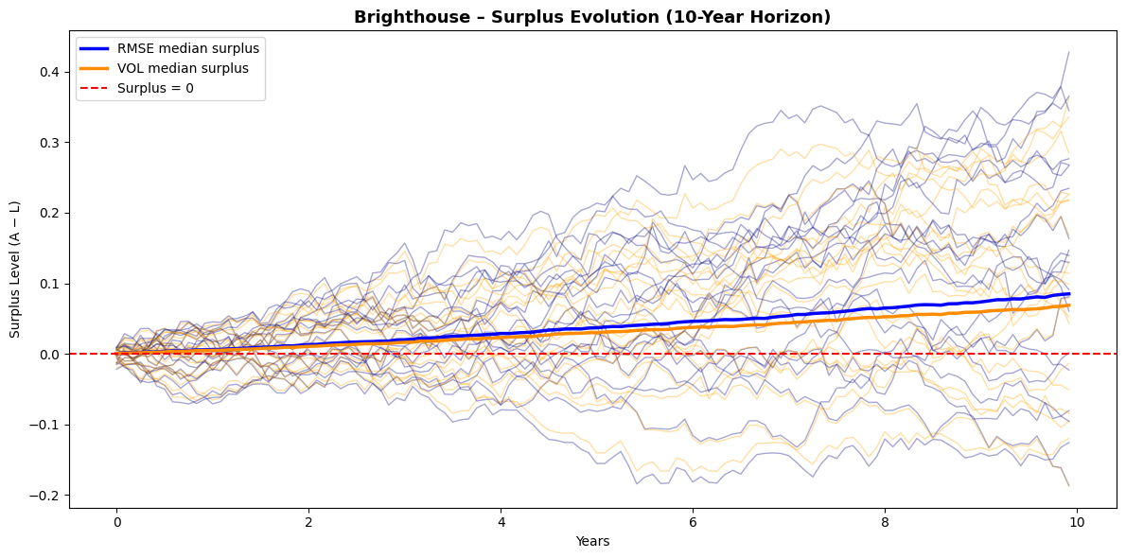

Appendix
- All the materials and sources used are located on this drive.
- This GitHub repository contains all the files for the project.

Brighthouse
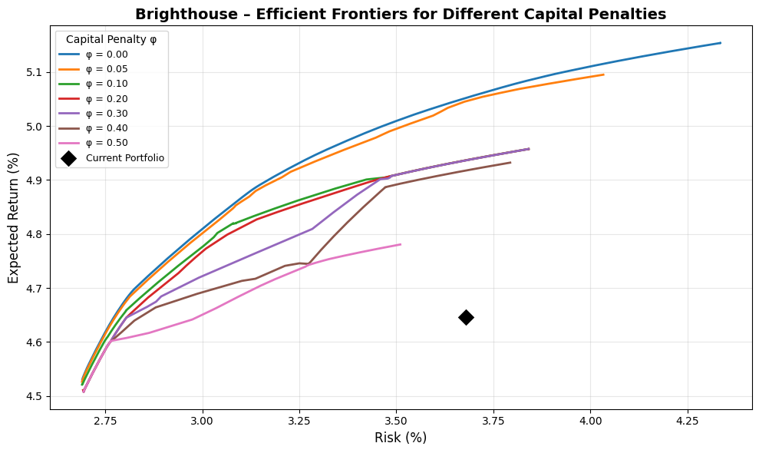
The impact of the capital penalty parameter (phi) further clarifies the relationship between regulatory friction and attainable efficiency. When the penalty is removed (phi=0), the unconstrained frontier reaches expected returns near 5.15% at 4% volatility, primarily by allocating more heavily to higher-spread, capital-intensive assets such as high-yield credit and private equity. As phi increases, the frontier shifts downward and flattens, favoring capital-efficient sectors. At the realistic base case (phi=0.2), the efficient frontier still dominates the current portfolio, with the utility-maximizing configuration around 3.0% risk and 4.9% return. Beyond phi=0.4, expected returns decline by roughly 20–25 basis points at comparable risk, as the optimizer concentrates almost entirely in AAA/AA public credit, ABS, and high-grade private placements. The frontier also becomes visibly shorter and kinked as phi rises. This occurs because the capital penalty effectively removes the most capital-intensive assets from the feasible set, causing the optimizer to jump between a small number of discrete efficient combinations rather than tracing a smooth risk-return tradeoff. As higher-phi portfolios cluster around similar low-RBC fixed income segments, the range of feasible volatility narrows, producing a truncated, segmented frontier. This behavior is typical when regulatory capital constraints dominate portfolio dynamics, reinforcing how RBC frictions compress the efficient opportunity set even before liquidity or diversification limits are reached.
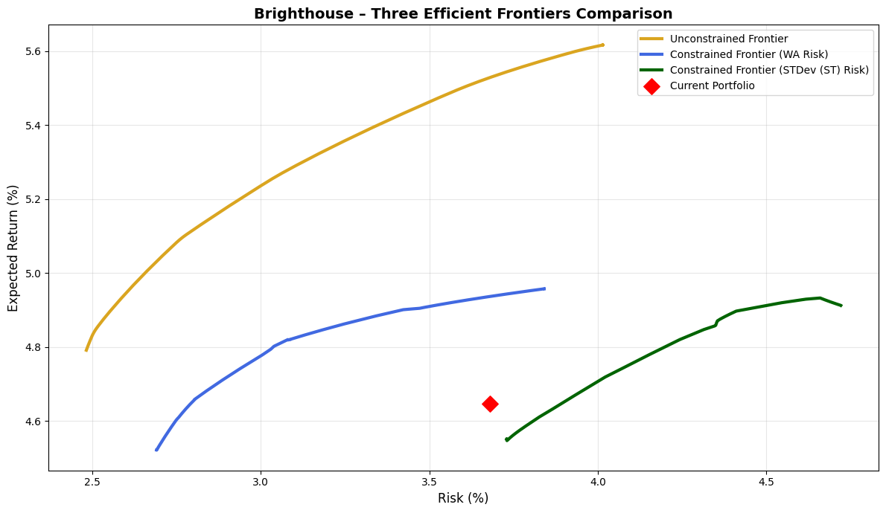
A final comparison between the unconstrained and realistically constrained frontiers quantifies the implementation gap. The unconstrained theoretical frontier lies roughly 70 basis points above the constrained one across the same risk range, largely due to the imposed 10% per-asset caps, the no-leverage condition, and the positive capital penalty. Despite these restrictions, Brighthouse’s current allocation remains below even the constrained frontier, confirming that substantial improvement is achievable without relaxing policy limits or increasing balance-sheet risk. The second plot also introduces an additional constrained frontier constructed using the short-term standard deviation (STDEV) as the sole risk measure, in contrast to the weighted-average (WA) measure that combines short-term volatility with long-term uncertainty (RMSFE). The WA approach, as discussed earlier, better reflects the multi-horizon risk exposure of life insurers by integrating both market and liability-duration perspectives, while the STDEV frontier captures only short-term mark-to-market sensitivity. The two risk definitions lead to visibly different efficient sets: the WA-based frontier lies further left, emphasizing structural balance-sheet resilience, whereas the STDEV-based frontier appears steeper and more right-shifted, reflecting higher instantaneous volatility but limited duration exposure. Together, these frontiers highlight the tradeoff between short-term accounting volatility and long-term surplus stability. The constrained efficient portfolios, particularly those around 3.0–3.2% risk and 4.8% return under the WA metric, represent a realistic strategic target consistent with Brighthouse’s liability structure and surplus-management philosophy.
From a strategic perspective, this analysis suggests that Brighthouse could materially enhance surplus efficiency through measured reallocation rather than structural transformation. The optimal adjustments would involve reducing reliance on commercial mortgage whole loans in favor of securitized exposures and private placements, modestly extending portfolio duration toward the seven-year range, and maintaining disciplined exposure to high-RBC sectors. The result is a portfolio that delivers roughly 20 basis points higher expected return, 60 basis points lower risk, and nearly one percentage point less capital usage, while maintaining strong credit quality and liability alignment. In short, Brighthouse’s portfolio is prudently constructed but not positioned on the efficient frontier; by realigning toward the most RBC-efficient sources of yield, it could meaningfully improve long-term surplus generation without compromising solvency resilience.

Corebridge
Corebridge Financial, the former life and retirement division of AIG, has a diversified liability structure spanning individual retirement products, group pensions, and institutional spread-based businesses. Its balance sheet combines retail annuities with large blocks of group retirement and pension-risk-transfer contracts, giving it one of the most balanced liability mixes among U.S. life insurers. The firm’s liability structure is characterized by moderately long duration, meaningful exposure to guaranteed payout obligations, and a stable flow of institutional funding agreements.
To approximate this structure, I modeled Corebridge’s liability profile with 25% of expected cash flows in the short bucket, 55% in the medium bucket, and 20% in the long bucket, corresponding to an average liability duration of about 8.0 years. This allocation reflects its blend of individual and institutional business, where the combination of retail annuities and pension-like exposures produces a moderately longer and more convex liability profile than Brighthouse’s. The higher share of long-duration liabilities implies a somewhat stronger need for asset duration extension and spread stability.
Metric/Asset | Current | Port A | Port B | Port C | Port D | Max Utility
Expected Return (%) | 4.78 | 4.56 | 4.70 | 4.78 | 4.83 | 4.73
Risk (%) | 4.12 | 2.72 | 2.93 | 3.14 | 3.36 | 2.98
Sharpe Ratio | 0.19 | 0.21 | 0.24 | 0.25 | 0.25 | 0.24
Avg FI Credit Rating | A+ | AA- | AA- | AA- | AA- | AA-
FI Duration (years) | 6.18 | 6.53 | 6.52 | 6.55 | 6.57 | 6.52
Net Duration (years) | 0.58 | 0.93 | 0.91 | 0.94 | 0.97 | 0.92
Capital Use (%) | 1.72 | 0.57 | 0.72 | 0.80 | 0.83 | 0.75
US Treasuries, Short/Intermediate | 0.2 | 9.9 | 5.5 | 5.3 | 4.3 | 5.5
US Treasuries, Long | 0.3 | 0.0 | 0.7 | 1.7 | 3.1 | 0.9
US Taxable Munis | 1.9 | 4.9 | 0.4 | 0.2 | 0.1 | 0.3
Global ex-US Government, hedged | 1.8 | 0.0 | 0.0 | 0.0 | 0.0 | 0.0
US Public Corporates IG AAA | 2.8 | 10.0 | 9.9 | 9.7 | 9.5 | 9.9
US Public Corporates IG AA | 5.5 | 9.8 | 7.6 | 6.7 | 5.6 | 7.2
US Public Corporates IG A | 8.3 | 9.7 | 9.8 | 9.8 | 9.6 | 9.7
US Public Corporates IG BBB | 18.8 | 0.2 | 2.5 | 2.9 | 3.1 | 2.4
US Public Corporates, HY Intermediate | 1.3 | 0.0 | 0.2 | 0.7 | 1.2 | 0.4
US Public Corporates, HY Long | 1.6 | 0.0 | 1.8 | 3.0 | 3.2 | 2.3
Global ex-US Corporates, hedged | 0.0 | 10.0 | 8.7 | 4.2 | 0.8 | 8.0
Residential Mortgage-Backed Securities (RMBS) | 6.8 | 6.0 | 10.0 | 9.9 | 10.0 | 10.0
Commercial Mortgage-Backed Securities (CMBS) | 4.1 | 9.2 | 9.6 | 9.8 | 9.6 | 9.6
Asset-Backed Securities (ABS) | 12.8 | 0.1 | 2.7 | 4.9 | 7.1 | 3.1
Corporate IG Private Placement A | 4.5 | 10.0 | 10.0 | 10.0 | 10.0 | 10.0
Corporate IG Private Placement BBB | 5.1 | 10.0 | 10.0 | 10.0 | 10.0 | 10.0
Corporate HY Private (Leveraged Loans) | 0.8 | 0.0 | 0.5 | 0.5 | 0.3 | 0.5
Residential Mortgage Whole Loans | 5.5 | 10.0 | 10.0 | 10.0 | 10.0 | 10.0
Commercial Mortgage Whole Loans | 15.6 | 0.0 | 0.2 | 0.6 | 2.4 | 0.2
Private Equity | 2.5 | 0.2 | 0.0 | 0.0 | 0.0 | 0.0
Real Estate (via partnerships, equity) | 0.0 | 0.0 | 0.0 | 0.0 | 0.0 | 0.0
On the asset side, Corebridge’s general account exhibits a distinctly spread-optimized structure. As of 2025, its portfolio is heavily allocated to public investment-grade credit (35 percent), structured products including ABS, RMBS, and CMBS (approximately 25% combined), and private placements (around 10% each in A and BBB-rated tranches). The remaining assets are split across commercial mortgage loans, alternative investments, and government securities. The overall composition produces an average fixed-income rating of A+, a duration of 6.2 years, and a modest positive net duration gap of 0.6 years relative to liabilities, indicating that assets are slightly longer than modeled obligations. The modeled capital utilization of 1.7% reflects efficient deployment of high-quality spread assets while maintaining regulatory flexibility.
Under my robust optimization framework, Corebridge’s current portfolio appears broadly efficient but still exhibits measurable suboptimality relative to the simulated frontier. The current mix, with an expected return of 4.78% and volatility of 4.12 percent, lies below both the baseline and mean efficient frontiers. The optimizer identifies several alternative portfolios that achieve meaningfully higher efficiency: for instance, Portfolios B through D deliver expected returns between 4.7 and 4.83% with substantially lower volatility in the 2.9–3.4% range. The maximum-utility portfolio, which balances expected return against surplus variance at λ=8, achieves a 4.73% return with 2.98% risk, improving the Sharpe ratio from 0.19 in the current allocation to approximately 0.24. These results imply that Corebridge’s current mix could realize a 100–120 basis point reduction in surplus volatility while maintaining roughly the same expected return.
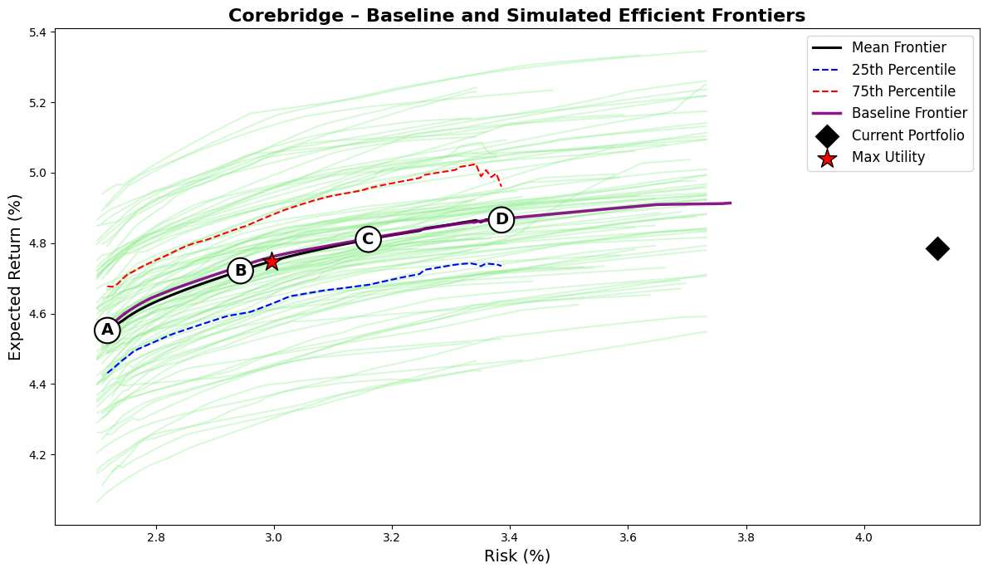
The structure of the optimized portfolios reveals where these gains originate. Across the frontier, the optimizer significantly reduces exposure to BBB-rated public corporates (from nearly 19% to below 3 percent) and reallocates toward higher-rated investment-grade credit and structured spread assets. Allocations to A and AA-rated public corporates increase, while private placements and securitized assets such as RMBS, CMBS, and residential mortgage loans reach their 10% caps. These sectors combine strong spreads with favorable capital treatment, enhancing surplus efficiency. The optimizer also cuts commercial mortgage whole loans, a 15.6% current position, replacing them with securitized alternatives that deliver comparable yield with lower capital intensity.
Unlike Brighthouse, Corebridge’s optimizer retains limited positions in global ex-U.S. corporates and Treasuries to preserve liquidity and rate sensitivity, consistent with its institutional liability mix. Non-core holdings such as global sovereigns, private equity, and real estate are eliminated due to weak capital-adjusted returns. As a result, capital use declines from 1.72% to about 0.75 percent, marking a 55% improvement in efficiency with no loss in return or duration alignment. The efficient frontier for Corebridge is flatter than Brighthouse’s, reflecting its already optimized exposure to high-quality spread assets. However, the 25th–75th percentile spread of roughly 40 basis points shows continued sensitivity to return and correlation assumptions, particularly for structured and private credit. The mean and baseline frontiers indicate that expected returns of 4.75–4.80% are attainable at 3% risk, whereas the current portfolio, at over 4% risk, remains well inside the efficiency envelope.

MetLife
MetLife’s balance sheet reflects its role as one of the largest and most diversified global life insurers, with a liability structure spanning institutional pension-risk-transfer (PRT) contracts, group benefits, and retail annuities. This mix results in a longer and more convex liability profile than most peers. The company’s liabilities are heavily influenced by pension and corporate benefit obligations, which exhibit long-term payout characteristics and limited optionality, combined with stable blocks of individual annuities and investment-oriented universal life. As a result, MetLife’s average liability duration is modeled around 8.5 years, higher than Brighthouse or Corebridge, with a broad tail extending beyond 20 years that captures its institutional and PRT exposures.
To approximate this profile, I modeled MetLife’s liability curve with 25% of cash flows in the short bucket, 50% in the medium bucket, and 25% in the long bucket, reflecting its diversified yet long-biased obligations. The liability convexity is notably higher than that of Corebridge or Brighthouse, suggesting greater exposure to reinvestment and long-term yield risk. This structure implies that MetLife’s asset allocation strategy must balance long-duration yield capture against capital efficiency and reinvestment flexibility.
Metric/Asset | Current | Port A | Port B | Port C | Port D | Max Utility
Expected Return (%) | 4.50 | 4.55 | 4.72 | 4.81 | 4.87 | 4.71
Risk (%) | 3.71 | 2.71 | 2.98 | 3.25 | 3.50 | 2.97
Sharpe Ratio | 0.13 | 0.20 | 0.24 | 0.25 | 0.25 | 0.24
Avg FI Credit Rating | AA- | AA- | AA- | AA- | AA- | AA-
FI Duration (years) | 6.15 | 6.57 | 6.63 | 6.88 | 7.07 | 6.62
Net Duration (years) | -0.21 | 0.21 | 0.27 | 0.53 | 0.71 | 0.26
Capital Use (%) | 2.63 | 0.56 | 0.74 | 0.78 | 0.81 | 0.73
US Treasuries, Short/Intermediate | 4.0 | 9.9 | 4.5 | 2.9 | 1.7 | 4.5
US Treasuries, Long | 3.9 | 0.0 | 1.3 | 4.6 | 7.5 | 1.3
US Taxable Munis | 2.4 | 5.5 | 0.8 | 0.7 | 0.3 | 0.8
Global ex-US Government, hedged | 10.3 | 0.0 | 0.0 | 0.0 | 0.0 | 0.0
US Public Corporates IG AAA | 1.6 | 10.0 | 10.0 | 10.0 | 9.3 | 10.0
US Public Corporates IG AA | 3.2 | 9.9 | 7.4 | 7.0 | 5.1 | 7.5
US Public Corporates IG A | 4.8 | 9.7 | 9.8 | 9.8 | 9.7 | 9.8
US Public Corporates IG BBB | 3.8 | 0.1 | 3.1 | 3.3 | 3.7 | 3.1
US Public Corporates, HY Intermediate | 0.3 | 0.0 | 0.4 | 0.7 | 0.9 | 0.4
US Public Corporates, HY Long | 0.3 | 0.0 | 1.9 | 3.0 | 3.6 | 1.8
Global ex-US Corporates, hedged | 14.3 | 10.0 | 8.4 | 3.5 | 0.5 | 8.5
Residential Mortgage-Backed Securities (RMBS) | 9.9 | 5.7 | 9.9 | 9.9 | 9.9 | 9.9
Commercial Mortgage-Backed Securities (CMBS) | 2.3 | 9.0 | 9.2 | 9.3 | 9.2 | 9.2
Asset-Backed Securities (ABS) | 5.1 | 0.1 | 2.4 | 3.7 | 5.0 | 2.3
Corporate IG Private Placement A | 4.0 | 10.0 | 10.0 | 10.0 | 10.0 | 10.0
Corporate IG Private Placement BBB | 1.6 | 10.0 | 10.0 | 10.0 | 9.9 | 10.0
Corporate HY Private (Leveraged Loans) | 0.2 | 0.0 | 0.5 | 0.3 | 0.1 | 0.5
Residential Mortgage Whole Loans | 7.0 | 10.0 | 10.0 | 10.0 | 10.0 | 10.0
Commercial Mortgage Whole Loans | 14.0 | 0.0 | 0.4 | 1.3 | 3.6 | 0.4
Private Equity | 3.4 | 0.1 | 0.0 | 0.0 | 0.0 | 0.0
Real Estate (via partnerships, equity) | 3.4 | 0.0 | 0.0 | 0.0 | 0.0 | 0.0
MetLife’s general account investments embody that balance. As of 2025, its portfolio allocates roughly 28% to public investment-grade corporates, 27% to private credit, 17% to structured securities, and over 20% to government and sovereign exposures. The remaining 7% represents private equity and real estate investments. This blend yields an average fixed-income credit quality of AA-, a duration of 6.2 years, and a small negative net duration gap of -0.2 years relative to the modeled liability book, consistent with the company’s disciplined asset-liability management framework. The modeled capital utilization of 2.6% is higher than peers such as Corebridge or Brighthouse, reflecting the company’s broader use of global and long-duration credit exposures, which attract higher RBC charges despite their high quality.
Under my robust optimization framework, MetLife’s current portfolio exhibits moderate inefficiency relative to its efficient frontier. The current mix achieves an expected return of 4.50% at 3.71% volatility, placing it below both the baseline and mean frontiers. The optimizer identifies several portfolios that achieve superior risk-adjusted performance without increasing capital use. The maximum-utility configuration, corresponding to λ=8, delivers a 4.71% expected return at 2.97% risk, improving the Sharpe ratio from 0.13 to 0.24 while cutting volatility by nearly 75 basis points. Portfolios C and D, which represent higher-risk points along the frontier, achieve returns up to 4.87% with volatility near 3.5 percent, indicating a flatter risk–return slope than in other insurers’ results.
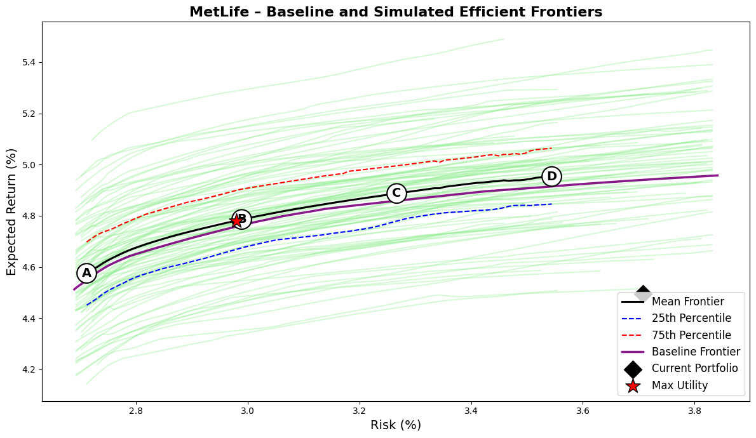
The composition of optimized portfolios highlights how these gains are achieved. The optimizer sharply reduces allocations to lower-efficiency holdings such as global ex-U.S. government bonds (10% of the current portfolio) and commercial mortgage whole loans (14 percent), both of which offer limited incremental spread relative to their capital charges. These assets are replaced with higher-yielding, RBC-efficient spread sectors: RMBS and CMBS reach their 10% caps, residential mortgage whole loans are maintained at the maximum 10 percent, and private placements (both A and BBB tranches) are fully utilized. Allocations to long Treasuries and long-duration investment-grade credit also increase slightly, better aligning the asset duration with the longer liability term structure. Capital use falls from 2.63% to approximately 0.73% in the optimized portfolios, reflecting a significant gain in capital efficiency while preserving MetLife’s strong credit profile (AA- average).
MetLife’s efficient frontier is smoother and slightly steeper than those of Brighthouse and Corebridge, consistent with its diversified global exposure and the availability of multiple high-quality spread assets. The optimizer’s simulated frontiers exhibit a relatively tight dispersion, with the 25th to 75th percentile range spanning about 30 basis points of expected return across scenarios. This indicates that the portfolio’s efficiency improvements are not sensitive to small changes in capital market assumptions, but rather stem from structural reallocation toward RBC-efficient sectors.
The improvement in surplus efficiency is accompanied by a modest extension of fixed-income duration from 6.15 to about 6.6–7.1 years and the closure of the duration gap relative to liabilities. Unlike Corebridge or Brighthouse, MetLife’s optimization places less emphasis on reducing total risk and more on aligning the asset and liability profiles while maintaining strong capital discipline. The result is a more balanced surplus risk profile, with roughly one percentage point less capital consumption and about 20 basis points higher expected return at comparable volatility.

Principal
Principal Financial Group’s balance sheet structure reflects its dual identity as both a U.S. life insurer and a global retirement and asset management platform. The company operates with a diversified liability mix that combines individual annuities, institutional retirement plans, and spread-based general account products. This results in a moderately long liability profile, though shorter and less convex than MetLife’s due to Principal’s emphasis on defined-contribution retirement and fixed deferred annuity businesses. In modeling the firm’s liability structure, I allocated 30% of cash flows to the short bucket, 55% to the medium bucket, and 15% to the long bucket, implying an average liability duration of approximately 7.0 years. This reflects its relatively liquid liability base compared to more institutionally oriented peers such as MetLife and Corebridge.
Principal’s general account asset mix exhibits a clear bias toward spread generation within a conservative credit risk framework. As of 2025, the company allocates roughly 34% of its portfolio to public investment-grade corporates, 25% to private placements, 15% to structured products (ABS, CMBS, RMBS), and 13% to commercial mortgage loans, with smaller positions in government securities and alternatives. The overall fixed-income portfolio carries an average rating of A+, a duration of 6.5 years, and a modestly positive net duration gap of 0.6 years relative to modeled liabilities. The capital utilization of 2.4% is somewhat elevated compared with Brighthouse or Corebridge, reflecting Principal’s larger allocations to BBB-rated public credit and commercial mortgages, both of which attract higher RBC charges despite their stable cash flows.
Metric/Asset | Current | Port A | Port B | Port C | Port D | Max Utility
Expected Return (%) | 4.83 | 4.54 | 4.71 | 4.80 | 4.85 | 4.74
Risk (%) | 3.96 | 2.71 | 2.96 | 3.21 | 3.45 | 3.02
Sharpe Ratio | 0.21 | 0.20 | 0.24 | 0.25 | 0.25 | 0.24
Avg FI Credit Rating | A+ | AA- | AA- | AA- | AA- | AA-
FI Duration (years) | 6.49 | 6.61 | 6.60 | 6.74 | 6.82 | 6.63
Net Duration (years) | 0.56 | 0.68 | 0.67 | 0.82 | 0.90 | 0.70
Capital Use (%) | 2.42 | 0.56 | 0.73 | 0.80 | 0.81 | 0.76
US Treasuries, Short/Intermediate | 0.7 | 9.9 | 4.6 | 3.9 | 2.5 | 4.4
US Treasuries, Long | 0.8 | 0.0 | 0.9 | 3.1 | 5.6 | 1.3
US Taxable Munis | 6.0 | 6.5 | 0.8 | 0.5 | 0.4 | 0.6
Global ex-US Government, hedged | 0.5 | 0.0 | 0.0 | 0.0 | 0.0 | 0.0
US Public Corporates IG AAA | 3.0 | 10.0 | 9.9 | 9.7 | 8.9 | 9.9
US Public Corporates IG AA | 4.5 | 10.0 | 8.1 | 7.0 | 5.2 | 8.0
US Public Corporates IG A | 9.0 | 9.8 | 9.9 | 9.8 | 9.4 | 9.9
US Public Corporates IG BBB | 19.4 | 0.0 | 2.6 | 2.8 | 2.7 | 2.5
US Public Corporates, HY Intermediate | 0.8 | 0.0 | 0.4 | 0.7 | 1.0 | 0.5
US Public Corporates, HY Long | 1.0 | 0.0 | 2.1 | 3.5 | 3.5 | 2.6
Global ex-US Corporates, hedged | 0.0 | 10.0 | 8.5 | 4.3 | 1.1 | 7.9
Residential Mortgage-Backed Securities (RMBS) | 3.6 | 4.9 | 9.9 | 9.9 | 10.0 | 9.9
Commercial Mortgage-Backed Securities (CMBS) | 5.0 | 8.7 | 9.4 | 9.3 | 9.3 | 9.3
Asset-Backed Securities (ABS) | 6.6 | 0.1 | 2.5 | 4.2 | 6.6 | 2.6
Corporate IG Private Placement A | 6.3 | 10.0 | 10.0 | 10.0 | 10.0 | 10.0
Corporate IG Private Placement BBB | 7.4 | 10.0 | 10.0 | 10.0 | 10.0 | 10.0
Corporate HY Private (Leveraged Loans) | 0.7 | 0.0 | 0.3 | 0.2 | 0.1 | 0.3
Residential Mortgage Whole Loans | 6.6 | 10.0 | 10.0 | 10.0 | 10.0 | 10.0
Commercial Mortgage Whole Loans | 13.2 | 0.0 | 0.2 | 1.1 | 3.5 | 0.3
Private Equity | 3.4 | 0.1 | 0.0 | 0.0 | 0.0 | 0.0
Real Estate (via partnerships, equity) | 1.7 | 0.0 | 0.0 | 0.0 | 0.0 | 0.0
Under my robust surplus optimization framework, Principal’s current portfolio appears generally well positioned but not fully efficient. The current mix delivers an expected return of 4.83% at 3.96% risk, which lies below both the baseline and mean simulated efficient frontiers. The optimizer identifies alternative portfolios that improve either risk-adjusted returns or capital efficiency without materially altering duration or credit quality. The maximum-utility portfolio, at λ=8, achieves an expected return of 4.74% at only 3.02% volatility, raising the Sharpe ratio from 0.21 to 0.24 while reducing risk by nearly one full percentage point. Portfolios C and D, representing higher-risk configurations, reach expected returns up to 4.85% with volatility near 3.4 percent, implying that the company could preserve its return profile while operating with substantially lower surplus volatility.
The optimized allocations illuminate where these gains arise. The optimizer systematically trims Principal’s large holdings of BBB-rated public corporates (19% currently) and commercial mortgage whole loans (13 percent) while reallocating toward private placements, securitized assets, and long-duration Treasuries. Both A- and BBB-rated private placements are pushed to their 10% caps, reflecting their strong spread-to-capital efficiency. RMBS, CMBS, and residential mortgage whole loans also reach or approach their caps, collectively accounting for nearly 30% of the efficient portfolios. These assets provide both yield enhancement and favorable RBC treatment relative to direct commercial loans. Conversely, allocations to ABS decline, as their relatively short duration and modest spread limit their efficiency contribution once other structured sectors are utilized. The optimizer maintains small allocations to long Treasuries and high-grade corporates to control duration and preserve liquidity, while private equity and real estate exposures are largely eliminated given their high capital intensity.
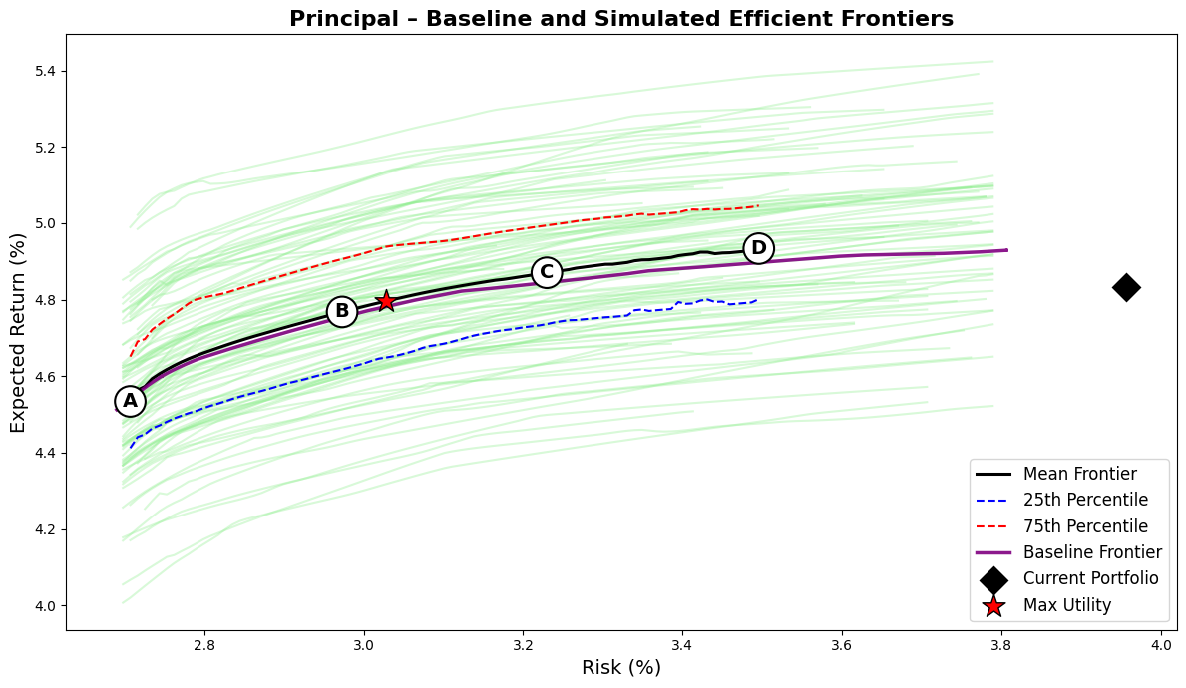
The optimized portfolios demonstrate a pronounced improvement in capital efficiency. Capital use declines from 2.42% in the current allocation to around 0.76% in the utility-maximizing portfolio, a 70% reduction, while the expected return remains nearly unchanged. This shift underscores how much Principal’s surplus efficiency is constrained not by risk appetite but by capital friction embedded in current sector weights. Average credit quality remains at AA-, while fixed-income duration modestly extends to 6.7–6.8 years, better aligning with the modeled liability term structure.
The efficient frontier for Principal exhibits a relatively smooth and steep shape compared with those of Brighthouse or Corebridge, reflecting the firm’s strong diversification across structured and private assets. The interquartile spread of simulated frontiers is tight, roughly ±25 basis points around the mean, suggesting that the efficient configurations are robust to moderate parameter uncertainty. The optimizer’s baseline and mean frontiers closely coincide, indicating that Principal’s opportunity set is well balanced and not excessively sensitive to return estimation noise. Strategically, these findings imply that Principal is close to its efficient frontier but has room for incremental improvement through internal reallocation rather than structural balance-sheet change. The key adjustments would involve shifting exposure from public BBB corporates and commercial mortgages into private placements and securitized assets, modestly extending duration, and reducing concentration in low-efficiency spread sectors. Such a transition would increase surplus stability, reduce capital consumption by roughly 1.5 percentage points, and preserve the company’s conservative credit risk posture.

Prudential
Prudential Financial’s general account reflects its position as one of the most globally diversified and liability-complex life insurers in the U.S. market. The company’s balance sheet supports a mix of individual annuities, group life and retirement contracts, and significant institutional insurance businesses, including pension-risk-transfer and funding agreement operations. This produces a liability structure that is both long-dated and internationally diversified. In modeling Prudential’s liability profile, I allocated 20% of expected cash flows to the short bucket, 55% to the medium bucket, and 25% to the long bucket, corresponding to an average liability duration of roughly 8.1 years. This configuration reflects the company’s long-duration annuity and pension obligations combined with more liquid short-term liabilities arising from funding agreements and separate account transfers.
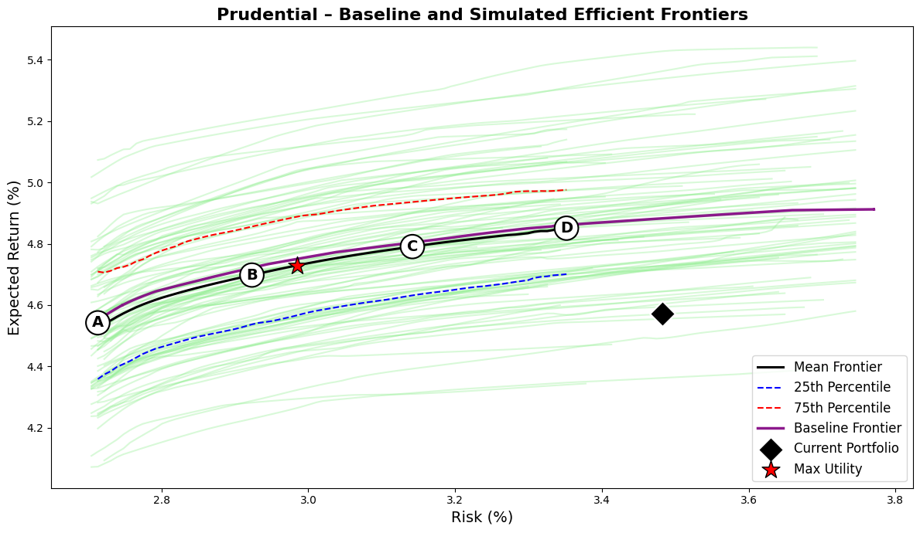
The asset portfolio that backs these liabilities is broad and globally diversified. As of June 2025, Prudential allocates approximately 36% of its general account to public investment-grade corporates, 20% to private placements, 15% to structured securities (ABS, RMBS, CMBS), and about 10% to commercial mortgage loans. Government securities, including both U.S. Treasuries and global sovereigns, account for 17% of total assets, while private equity and real estate collectively represent less than 3 percent. This mix results in an average fixed-income credit rating of AA-, a duration of 6.8 years, and a net duration gap of 1.3 years, meaning the asset base is slightly longer than modeled liabilities. The capital utilization rate of 1.7% is among the lowest in the peer group, reflecting the firm’s conservative credit posture and high share of high-grade, capital-efficient exposures.
Under my robust optimization framework, Prudential’s current portfolio is relatively efficient but not fully optimized. The existing mix achieves an expected return of 4.57% with 3.48% volatility, placing it slightly below the mean and baseline efficient frontiers. The optimizer identifies several alternative allocations that achieve comparable or higher returns at significantly lower risk. The maximum-utility configuration (λ=8) delivers a 4.72% expected return with only 2.97% volatility, improving the Sharpe ratio from 0.16 to 0.24 while reducing risk by more than 50 basis points. Portfolios C and D, which operate further along the risk spectrum, reach expected returns up to 4.82% with volatility between 3.1 and 3.3 percent, implying that the current portfolio could either increase return by 20–25 basis points or reduce surplus risk by 70–80 basis points without additional capital cost.
Metric/Asset | Current | Port A | Port B | Port C | Port D | Max Utility
Expected Return (%) | 4.57 | 4.56 | 4.69 | 4.77 | 4.82 | 4.72
Risk (%) | 3.48 | 2.71 | 2.91 | 3.13 | 3.32 | 2.97
Sharpe Ratio | 0.16 | 0.20 | 0.24 | 0.25 | 0.25 | 0.24
Avg FI Credit Rating | AA- | AA- | AA- | AA- | AA- | AA-
FI Duration (years) | 6.84 | 6.53 | 6.48 | 6.50 | 6.53 | 6.48
Net Duration (years) | 1.27 | 0.97 | 0.91 | 0.94 | 0.97 | 0.92
Capital Use (%) | 1.66 | 0.57 | 0.71 | 0.79 | 0.82 | 0.74
US Treasuries, Short/Intermediate | 2.5 | 9.9 | 5.6 | 5.3 | 3.7 | 5.6
US Treasuries, Long | 2.6 | 0.0 | 0.3 | 0.9 | 1.9 | 0.4
US Taxable Munis | 1.4 | 5.1 | 0.4 | 0.4 | 0.3 | 0.4
Global ex-US Government, hedged | 14.6 | 0.0 | 0.0 | 0.0 | 0.0 | 0.0
US Public Corporates IG AAA | 2.7 | 10.0 | 9.8 | 9.6 | 9.3 | 9.8
US Public Corporates IG AA | 5.4 | 10.0 | 7.9 | 7.2 | 6.8 | 7.4
US Public Corporates IG A | 8.2 | 9.6 | 9.9 | 9.9 | 9.8 | 9.9
US Public Corporates IG BBB | 7.7 | 0.1 | 2.7 | 2.7 | 3.1 | 2.4
US Public Corporates, HY Intermediate | 0.8 | 0.0 | 0.4 | 0.8 | 1.0 | 0.6
US Public Corporates, HY Long | 0.9 | 0.0 | 1.3 | 2.9 | 3.3 | 2.0
Global ex-US Corporates, hedged | 6.0 | 10.0 | 8.8 | 4.9 | 1.6 | 8.1
Residential Mortgage-Backed Securities (RMBS) | 1.0 | 5.7 | 10.0 | 10.0 | 10.0 | 10.0
Commercial Mortgage-Backed Securities (CMBS) | 2.4 | 9.3 | 9.6 | 9.6 | 9.7 | 9.5
Asset-Backed Securities (ABS) | 4.6 | 0.0 | 2.4 | 4.1 | 6.4 | 2.8
Corporate IG Private Placement A | 13.4 | 10.0 | 10.0 | 10.0 | 10.0 | 10.0
Corporate IG Private Placement BBB | 6.3 | 10.0 | 10.0 | 10.0 | 10.0 | 10.0
Corporate HY Private (Leveraged Loans) | 1.4 | 0.0 | 0.5 | 0.4 | 0.3 | 0.5
Residential Mortgage Whole Loans | 5.2 | 10.0 | 10.0 | 10.0 | 10.0 | 10.0
Commercial Mortgage Whole Loans | 10.4 | 0.0 | 0.4 | 1.3 | 2.9 | 0.6
Private Equity | 2.1 | 0.2 | 0.0 | 0.0 | 0.0 | 0.0
Real Estate (via partnerships, equity) | 0.5 | 0.0 | 0.0 | 0.0 | 0.0 | 0.0
The composition of the efficient frontier portfolios highlights how these improvements are achieved. The optimizer reduces Prudential’s exposure to lower-return, high-capital sectors such as global ex-U.S. government bonds (currently 14.6% of the portfolio) and reallocates that capital toward structured credit and private placements. RMBS, CMBS, and residential mortgage whole loans each reach their 10% caps across the efficient portfolios, reflecting their superior return-to-capital characteristics. Both A- and BBB-rated private placements are fully utilized, and allocations to BBB-rated public corporates decline from nearly 8% to less than 3 percent. Long-duration Treasuries and AAA/AA-rated public corporates remain present to manage duration and maintain liquidity, while higher-capital sectors such as private equity and real estate are minimized.
A notable feature of Prudential’s optimization results is the stability of capital efficiency across the frontier. Despite material changes in asset composition, capital use remains between 0.7 and 0.8% across all optimized portfolios, down from 1.7% currently. This reflects the firm’s inherently capital-efficient balance sheet, where a shift from global sovereigns to structured U.S. spread assets unlocks further surplus efficiency without increasing aggregate risk. The average credit quality remains at AA-, and fixed-income duration remains stable around 6.5 years, slightly improving liability alignment while preserving Prudential’s conservative risk posture. The interquartile spread between the 25th and 75th percentile simulated frontiers is narrow (about ±20 basis points), indicating that the company’s opportunity set is relatively robust to model uncertainty. The mean and baseline frontiers nearly coincide, underscoring the stability of Prudential’s risk-return trade-off even under parameter perturbations. Strategically, the analysis suggests that Prudential’s general account is already close to an efficient surplus configuration but could still enhance performance through targeted reallocations. The largest opportunities lie in reducing global sovereign exposure and marginally trimming lower-yielding BBB public credit in favor of structured and private spread assets.

Voya
Voya Financial’s general account structure reflects its evolution from a traditional life insurance company into a retirement and asset management–focused institution. The firm’s liability profile is relatively short and liquid compared with other large U.S. life insurers, driven by its emphasis on defined contribution retirement products, fixed annuities, and funding agreement–backed securities (FABS). These lines of business produce a liability term structure with modest convexity and shorter average duration. I modeled Voya’s liabilities as having 35% of expected cash flows in the short bucket, 50% in the medium bucket, and 15% in the long bucket, corresponding to an average liability duration near 6.5 years. This configuration captures the company’s liquidity-sensitive funding model and its lower exposure to long-dated guarantees relative to peers like Prudential and MetLife.
Voya’s investment portfolio is well diversified across fixed income sectors but designed primarily for capital efficiency and liquidity management rather than maximum yield. As of 2025, its general account is composed of approximately 33% public investment-grade corporates, 21% private placements, 17% structured securities (RMBS, CMBS, and ABS), 10% commercial mortgage loans, and 17% in government securities. The remainder, roughly 5 percent, is invested in alternatives such as private equity and real estate. This allocation produces an average fixed-income rating of AA-, a duration of 6.2 years, and a net duration gap of 0.3 years, indicating close alignment with its liability profile. The modeled capital use of 2.2% is moderately high given Voya’s exposure to BBB-rated credit and structured assets but consistent with its spread-driven business model.
Metric/Asset | Current | Port A | Port B | Port C | Port D | Max Utility
Expected Return (%) | 4.82 | 4.55 | 4.71 | 4.80 | 4.85 | 4.72
Risk (%) | 3.62 | 2.71 | 2.96 | 3.21 | 3.45 | 2.99
Sharpe Ratio | 0.23 | 0.20 | 0.24 | 0.25 | 0.25 | 0.24
Avg FI Credit Rating | AA- | AA- | AA- | AA- | AA- | AA-
FI Duration (years) | 6.20 | 6.56 | 6.63 | 6.74 | 6.79 | 6.65
Net Duration (years) | 0.31 | 0.67 | 0.74 | 0.85 | 0.90 | 0.76
Capital Use (%) | 2.16 | 0.57 | 0.71 | 0.79 | 0.81 | 0.73
US Treasuries, Short/Intermediate | 0.7 | 10.0 | 4.1 | 4.0 | 3.0 | 4.0
US Treasuries, Long | 0.9 | 0.0 | 1.2 | 3.3 | 5.2 | 1.4
US Taxable Munis | 1.4 | 5.3 | 0.8 | 0.6 | 0.4 | 0.8
Global ex-US Government, hedged | 3.4 | 0.0 | 0.0 | 0.0 | 0.0 | 0.0
US Public Corporates IG AAA | 1.4 | 10.0 | 9.8 | 9.8 | 9.0 | 9.8
US Public Corporates IG AA | 4.0 | 9.8 | 8.5 | 6.9 | 5.5 | 8.3
US Public Corporates IG A | 5.1 | 9.8 | 9.8 | 9.7 | 9.5 | 9.8
US Public Corporates IG BBB | 8.3 | 0.2 | 2.7 | 2.8 | 2.8 | 2.7
US Public Corporates, HY Intermediate | 0.5 | 0.0 | 0.4 | 0.8 | 0.9 | 0.4
US Public Corporates, HY Long | 0.6 | 0.0 | 1.8 | 3.2 | 3.5 | 2.0
Global ex-US Corporates, hedged | 6.8 | 10.0 | 8.4 | 3.9 | 0.7 | 8.1
Residential Mortgage-Backed Securities (RMBS) | 9.9 | 5.8 | 10.0 | 10.0 | 10.0 | 10.0
Commercial Mortgage-Backed Securities (CMBS) | 8.1 | 8.9 | 9.3 | 9.4 | 9.4 | 9.3
Asset-Backed Securities (ABS) | 7.9 | 0.1 | 2.6 | 4.2 | 6.0 | 2.7
Corporate IG Private Placement A | 11.6 | 10.0 | 10.0 | 10.0 | 10.0 | 10.0
Corporate IG Private Placement BBB | 9.2 | 10.0 | 10.0 | 10.0 | 10.0 | 10.0
Corporate HY Private (Leveraged Loans) | 1.2 | 0.0 | 0.3 | 0.3 | 0.2 | 0.3
Residential Mortgage Whole Loans | 4.9 | 10.0 | 10.0 | 10.0 | 10.0 | 10.0
Commercial Mortgage Whole Loans | 9.8 | 0.0 | 0.2 | 1.3 | 4.0 | 0.3
Private Equity | 4.5 | 0.1 | 0.0 | 0.0 | 0.0 | 0.0
Real Estate (via partnerships, equity) | 0.0 | 0.0 | 0.0 | 0.0 | 0.0 | 0.0
Under my robust surplus optimization framework, Voya’s current portfolio exhibits mild sub-efficiency. The existing mix achieves an expected return of 4.82% at 3.62% volatility, placing it slightly inside both the baseline and mean efficient frontiers. The optimizer identifies portfolios that achieve equivalent returns with materially lower risk or modestly higher returns at similar risk. The maximum-utility portfolio (λ=8) achieves an expected return of 4.72% with only 2.99% volatility, improving the Sharpe ratio from 0.23 to 0.24 while reducing risk by over 60 basis points. Portfolios C and D deliver returns up to 4.85% at risk levels between 3.2 and 3.5 percent, confirming that Voya’s current positioning is close to efficient but not fully optimal.
The optimized portfolios reveal a consistent reallocation pattern that enhances both capital efficiency and liability matching. The optimizer significantly reduces allocations to commercial mortgage whole loans (9.8% currently) and BBB-rated public corporates (8.3 percent), redirecting this exposure toward private placements and structured credit. Both A- and BBB-rated private placements are fully utilized at their 10% caps, providing an attractive balance between yield and RBC efficiency. RMBS, CMBS, and residential mortgage whole loans are also pushed near their caps, reflecting their favorable capital treatment and yield contribution. Conversely, global ex-U.S. corporates and sovereigns are largely eliminated, as they offer limited incremental return relative to their correlation and capital costs. Small allocations to long Treasuries are retained to manage duration and provide liquidity.
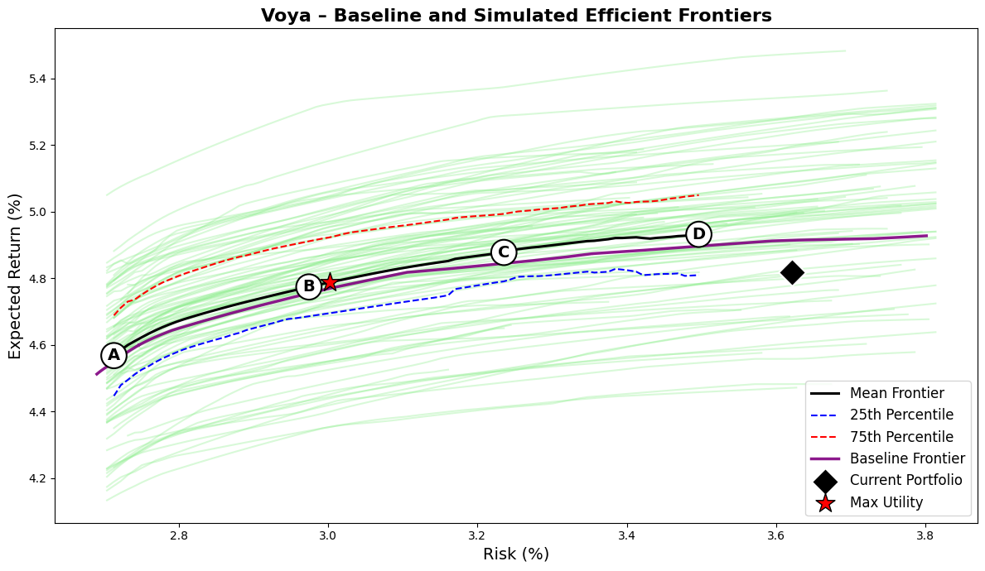
Across the efficient frontier, Voya’s portfolios maintain high credit quality (AA-), modestly extend fixed-income duration to around 6.7–6.8 years, and achieve a sharp improvement in capital efficiency. Capital use declines from 2.16% to roughly 0.73% in the optimized configurations, while expected returns remain nearly unchanged. The interquartile range of simulated frontiers is narrow, about ±25 basis points, suggesting that these improvements are robust to parameter uncertainty. The mean and baseline frontiers are closely aligned, confirming that the firm’s diversified spread base provides stable efficiency characteristics under plausible perturbations of market assumptions.
Strategically, these results indicate that Voya’s general account is already positioned near the efficient frontier but could capture incremental surplus efficiency through selective adjustments. The main opportunities lie in reducing exposure to capital-intensive commercial mortgage loans and BBB-rated public credit, reallocating that capital to private placements and structured spread sectors. Such adjustments would reduce surplus volatility, enhance capital efficiency, and maintain duration alignment with liabilities. The resulting configuration would preserve Voya’s conservative credit profile while improving expected surplus growth and capital deployment efficiency. Overall, Voya’s portfolio embodies a disciplined, risk-controlled balance between liquidity and spread income, consistent with its liability profile and retirement-focused business model, but it remains slightly short of the theoretical efficiency frontier achievable within its existing constraints.
 | US Treasuries, Short/Intermediate | US Treasuries, Long | US Taxable Munis | Global ex-US Government, hedged | US Public Corporates IG AAA | US Public Corporates IG AA | US Public Corporates IG A | US Public Corporates IG BBB | US Public Corporates, HY Intermediate | US Public Corporates, HY Long | Global ex-US Corporates, hedged | Residential Mortgage-Backed Securities | Commercial Mortgage-Backed Securities | Asset-Backed Securities | Corporate IG Private Placement A | Corporate IG Private Placement BBB | Corporate HY Private (Leveraged Loans) | Residential Mortgage Whole Loans | Commercial Mortgage Whole Loans | Private Equity | Real Estate (via partnerships, equity)
US Treasuries, Short/Intermediate | 1.0 | 0.9 | 0.5 | 0.8 | 0.9 | 0.7 | 0.6 | 0.5 | 0.0 | 0.1 | 0.7 | 0.8 | 0.2 | 0.3 | 0.2 | 0.1 | -0.2 | 0.8 | 0.2 | 0.0 | 0.0
US Treasuries, Long | 0.9 | 1.0 | 0.6 | 0.8 | 0.9 | 0.8 | 0.6 | 0.5 | 0.0 | 0.1 | 0.7 | 0.8 | 0.2 | 0.3 | 0.2 | 0.2 | -0.1 | 0.8 | 0.2 | 0.0 | 0.0
US Taxable Munis | 0.5 | 0.6 | 1.0 | 0.7 | 0.7 | 0.7 | 0.7 | 0.7 | 0.5 | 0.5 | 0.8 | 0.7 | 0.4 | 0.6 | 0.3 | 0.3 | 0.3 | 0.8 | 0.4 | 0.0 | 0.0
Global ex-US Government, hedged | 0.8 | 0.8 | 0.7 | 1.0 | 0.8 | 0.8 | 0.7 | 0.6 | 0.2 | 0.3 | 0.9 | 0.8 | 0.3 | 0.3 | 0.3 | 0.2 | 0.2 | 0.7 | 0.3 | 0.0 | 0.0
US Public Corporates IG AAA | 0.9 | 0.9 | 0.7 | 0.8 | 1.0 | 0.9 | 0.7 | 0.6 | 0.2 | 0.3 | 0.8 | 0.9 | 0.4 | 0.4 | 0.3 | 0.2 | -0.1 | 0.9 | 0.4 | 0.0 | 0.0
US Public Corporates IG AA | 0.7 | 0.8 | 0.7 | 0.8 | 0.9 | 1.0 | 1.0 | 0.9 | 0.5 | 0.6 | 0.9 | 0.8 | 0.5 | 0.5 | 0.4 | 0.4 | 0.3 | 0.8 | 0.5 | 0.0 | 0.1
US Public Corporates IG A | 0.6 | 0.6 | 0.7 | 0.7 | 0.7 | 1.0 | 1.0 | 0.9 | 0.6 | 0.7 | 0.9 | 0.7 | 0.6 | 0.6 | 0.4 | 0.4 | 0.4 | 0.8 | 0.6 | 0.1 | 0.1
US Public Corporates IG BBB | 0.5 | 0.5 | 0.7 | 0.6 | 0.6 | 0.9 | 0.9 | 1.0 | 0.8 | 0.8 | 1.0 | 0.6 | 0.6 | 0.7 | 0.5 | 0.5 | 0.6 | 0.7 | 0.6 | 0.0 | 0.0
US Public Corporates, HY Intermediate | 0.0 | 0.0 | 0.5 | 0.2 | 0.2 | 0.5 | 0.6 | 0.8 | 1.0 | 0.9 | 0.7 | 0.3 | 0.7 | 0.6 | 0.5 | 0.5 | 0.8 | 0.4 | 0.7 | 0.0 | 0.1
US Public Corporates, HY Long | 0.1 | 0.1 | 0.5 | 0.3 | 0.3 | 0.6 | 0.7 | 0.8 | 0.9 | 1.0 | 0.8 | 0.4 | 0.7 | 0.6 | 0.5 | 0.5 | 0.7 | 0.5 | 0.7 | 0.0 | 0.1
Global ex-US Corporates, hedged | 0.7 | 0.7 | 0.8 | 0.9 | 0.8 | 0.9 | 0.9 | 1.0 | 0.7 | 0.8 | 1.0 | 0.8 | 0.9 | 0.8 | 0.4 | 0.4 | 0.5 | 0.7 | 0.9 | -0.1 | -0.1
Residential Mortgage-Backed Securities | 0.8 | 0.8 | 0.7 | 0.8 | 0.9 | 0.8 | 0.7 | 0.6 | 0.3 | 0.4 | 0.8 | 1.0 | 0.3 | 0.4 | 0.2 | 0.2 | 0.0 | 1.0 | 0.3 | 0.0 | 0.0
Commercial Mortgage-Backed Securities | 0.2 | 0.2 | 0.4 | 0.3 | 0.4 | 0.5 | 0.6 | 0.6 | 0.7 | 0.7 | 0.9 | 0.3 | 1.0 | 0.4 | 0.5 | 0.4 | 0.4 | 0.8 | 1.0 | 0.0 | 0.2
Asset-Backed Securities | 0.3 | 0.3 | 0.6 | 0.3 | 0.4 | 0.5 | 0.6 | 0.7 | 0.6 | 0.6 | 0.8 | 0.4 | 0.4 | 1.0 | 0.5 | 0.4 | 0.5 | 0.8 | 0.5 | 0.0 | 0.1
Corporate IG Private Placement A | 0.2 | 0.2 | 0.3 | 0.3 | 0.3 | 0.4 | 0.4 | 0.5 | 0.5 | 0.5 | 0.4 | 0.2 | 0.5 | 0.5 | 1.0 | 1.0 | 0.2 | 0.3 | 0.5 | 0.2 | 0.2
Corporate IG Private Placement BBB | 0.1 | 0.2 | 0.3 | 0.2 | 0.2 | 0.4 | 0.4 | 0.5 | 0.5 | 0.5 | 0.4 | 0.2 | 0.4 | 0.4 | 1.0 | 1.0 | 0.2 | 0.3 | 0.4 | 0.1 | 0.2
Corporate HY Private (Leveraged Loans) | -0.2 | -0.1 | 0.3 | 0.2 | -0.1 | 0.3 | 0.4 | 0.6 | 0.8 | 0.7 | 0.5 | 0.0 | 0.4 | 0.5 | 0.2 | 0.2 | 1.0 | 0.1 | 0.4 | -0.2 | -0.2
Residential Mortgage Whole Loans | 0.8 | 0.8 | 0.8 | 0.7 | 0.9 | 0.8 | 0.8 | 0.7 | 0.4 | 0.5 | 0.7 | 1.0 | 0.8 | 0.8 | 0.3 | 0.3 | 0.1 | 1.0 | 0.8 | -0.1 | -0.1
Commercial Mortgage Whole Loans | 0.2 | 0.2 | 0.4 | 0.3 | 0.4 | 0.5 | 0.6 | 0.6 | 0.7 | 0.7 | 0.9 | 0.3 | 1.0 | 0.5 | 0.5 | 0.4 | 0.4 | 0.8 | 1.0 | 0.0 | 0.2
Private Equity | 0.0 | 0.0 | 0.0 | 0.0 | 0.0 | 0.0 | 0.1 | 0.0 | 0.0 | 0.0 | -0.1 | 0.0 | 0.0 | 0.0 | 0.2 | 0.1 | -0.2 | -0.1 | 0.0 | 1.0 | 0.7
Real Estate (via partnerships, equity) | 0.0 | 0.0 | 0.0 | 0.0 | 0.0 | 0.1 | 0.1 | 0.0 | 0.1 | 0.1 | -0.1 | 0.0 | 0.2 | 0.1 | 0.2 | 0.2 | -0.2 | -0.1 | 0.2 | 0.7 | 1.0

Cash and Foreign Currency Bonds
In this analysis, I intentionally exclude cash from the expected return modeling framework. Although cash is essential for liquidity management, it does not function as a strategic return driver over extended investment horizons. Empirical and industry research consistently demonstrates that cash historically underperforms risk-bearing assets such as bonds and equities across multi-year periods. Several factors underpin this long-term underperformance:
- Structural return deficiency: bonds allow reliable long-term return forecasting based on starting yields and embedded term premia. Cash, however, lacks such reliability, with short-term interest rates subject to significant fluctuations driven by central bank policy decisions rather than structural macroeconomic drivers such as long-term growth, inflation trends, or persistent risk premia.
- Forecasting limitations: empirically, the autocorrelation of cash return time series (1999-2025) is around 70% vs -10% for longer indices (long UST and corporate IG), the volatility and policy-dependent nature of short-term interest rates severely limits the stability and reliability of long-term cash return projections. Unlike longer-duration assets, cash has no term premium and responds predominantly to short-term monetary cycles rather than fundamental macroeconomic conditions.
- Portfolio role: from a portfolio construction standpoint, cash primarily serves as a liquidity buffer rather than a strategic asset. Institutional investors, particularly life insurers, typically maintain only minimal cash holdings (around 1–2%) to facilitate operational liquidity, meet transactional needs, or temporarily hold funds awaiting deployment into productive assets.
In my framework, foreign currency bonds are modeled using currency-hedged indexes rather than unhedged ones. The reason is that unhedged exposures introduce large amounts of uncompensated FX volatility, which in many cases dominates the bond return variance, as shown in the chart below. While one could make the case that foreign bonds provide diversification when domestic assets sell off alongside the currency, the evidence suggests that such offsets are weak (correlations are modest, around 0.25) and unstable over time. Moreover, correlation does not imply a reliable causal hedge.
Foreign currency volatility makes up the majority of the unhedged foreign currency bond risk
Life insurers and other institutional allocators do in practice allocate to foreign sovereign and corporate bonds, but on a hedged basis, since their mandate is to capture the bond risk premium rather than currency noise. Following this logic, I include foreign bond exposures in my CMA framework through hedged indexes, ensuring comparability to domestic bonds and aligning with real-world institutional implementation.
Credit Loss Adjustments
While Yield to Worst (YTW) serves as a conservative base case for return expectations, assuming the earliest possible redemption scenario, it does not account for credit losses arising from defaults or downgrades. YTW assumes contractual cash flows will be honored, which makes it insufficient for realistic modeling of credit-sensitive portfolios. To reflect this, I apply expected credit loss adjustment, using 10-year cumulative default probabilities by rating tier and assumed Loss-Given-Default (LGD). The figures in the final table are based on long-run Moody’s and S&P data, with assumed LGDs of 60% for corporates and lower for structured products. Sector-level estimates reflect a weighted average of underlying ratings.
Since the analysis is aimed at life insurers’ portfolios, which face probably the highest number of regulations among large institutional asset allocators, I am also adjusting the yields by how much capital drag each asset has, which in public fixed income space is dependent on the credit ratings. The table below shows the list of assets along with their assigned schedule NAIC papers, ratings, NAIC designations, and capital charges (times portfolio adjustment factor which accounts for the number of issuers in a given index, and which I assume to be around 500 for each index I take, with PAF of ~1).
Capital Charge
The capital charge drags the expected return as it ties up the capital that could be invested at the hurdle rate for the given company, which is also its cost of capital and I assume to be 10%. The typical RBC ratio (how much capital above the required charge they typically hold for a given asset) for life insurers is 4. However, in my analysis, I deal with capital charges through the objective function, where one of the terms I deduct from the expected portfolio return is it’s capital drag.
Standard Error vs RMSFE
If we compare the traditional (standard error) vs novel (RMSFE, not scaled) approaches to how wrong we could be in average return estimation, RMSFE beats the Standard Error estimation, with both considerably lower average level and interquartile range.
As expected, RMSFE is lower than traditional measure of average return volatility STERR

Public Equity
This section provides a comprehensive explanation of the methodology, rationale, and data inputs used to estimate strategic long-term expected returns for U.S. public equities within the Strategic Asset Allocation (SAA) framework. Even though I don’t include the public equity allocations for the optimal portfolios for life insurers (because they usually have <1% due to high RBC requirements), this analysis provides an important foundation for other types of allocators (endowments, SWFs) who allocate more to this asset class.

Unlike traditional top-down approaches, which often rely on index-level heuristics or aggregate macro projections, this analysis adopts a granular bottom-up structure, designed to be both cash-flow based and valuation-sensitive, while integrating structural economic insights and historical data patterns. Each step of the equity CMA construction reflects an effort to align financial modeling with the actual behaviors of public companies, equity markets, and sector-specific business models over time.
To begin with, the scope of the equity analysis is intentionally narrowed to U.S. large-cap equities only, and more specifically, to the eleven GICS sectors within the S&P 500 index. The rationale for this focused approach stems from both methodological and operational considerations:
- Bottom-up equity modeling at the sector level requires extensive historical data collection for constituent firms, including detailed variables such as dividends, buybacks, and growth estimates.
- Expanding this framework to multiple geographies or indices would have proven logistically prohibitive and would risk compromising the rigor of the estimation.
- Restricting the analysis to the U.S. large-cap equity universe avoids the complications of FX forecasting and cross-border tax and liquidity assumptions.
Historical data from Bloomberg were collected for all eleven sector-specific equity indices from 2003 to 2025, specifically the Bloomberg tickers corresponding to each sector such as B500CT (Consumer Staples), B500E (Energy), B500I (Industrials), and so forth. The monthly time series included index level prices, dividend yields, trailing-twelve-month (TTM) earnings per share (EPS), price-to-earnings (P/E) ratios, and net profit margins. This multi-decade data foundation ensures a sufficiently long observation window to capture both cyclical and structural patterns, including periods of economic expansion, contraction, and crisis.
The foundational component of the expected return estimation is the concept of a "cash yield," the equity market's closest analog to a bond's starting yield. Accounting earnings can be systematically manipulated and often diverge from the underlying economic reality that investors should rely on, making cash-based measures significantly more robust. Academic literature and regulatory commentary consistently highlight that companies frequently engage in earnings management through accrual adjustments, one-off items, or strategic timing of expenses and revenues, which distorts reported earnings quality. Earnings may reflect accounting judgment rather than actual cash flows, rendering traditional P/E or EPS-based return models vulnerable to these distortions. In contrast, empirical evidence suggests that shareholder yield components, dividends and buybacks, are harder to manipulate and better reflect real cash returned to investors. Dividend-paying stocks, on average, exhibit lower return volatility, even when controlling for firm size, indicating that cash distributions are associated with greater stability and transparency. Moreover, accrual-based earnings quality improves only when internal controls are strong, otherwise companies may still distort earnings figures even in ostensibly well-governed firms. These findings reinforce the superiority of using cash-based yields as forward return anchors in equity return modeling framework, dividends and buybacks cannot be fabricated, they reflect real value returned to shareholders, and they are less subject to managerial discretion or manipulation.
For equities, this is defined as the sum of dividend yield and share buyback yield. While dividend yield data are readily available at the sector index level, buyback data is not directly accessible in aggregated form. To overcome this, a bottom-up methodology was employed:
- For each year-end, the constituent companies of every sector index were retrieved via Bloomberg's Excel API.
- Key data included market capitalization, share prices, shares outstanding, and actual buyback amounts.
- These values were used to compute market-capitalization-weighted buyback yields at the sector level, creating a robust and replicable proxy for shareholder yield.
Buyback yields have considerably increased since 2012
Over the past two decades, share buybacks have become a structurally important component of shareholder return policy across nearly all U.S. equity sectors. As illustrated in the chart, buyback yields were negligible or even negative during the early 2000s but began rising meaningfully post-2010, with an especially sharp acceleration following the 2017 corporate tax reform and the COVID-19 recovery period. By 2022–2025, many sectors, including Financials, Technology, and Industrials, consistently delivered buyback yields in the 3% to 6% range, rivaling or exceeding their dividend yields. This shift reflects a broader transformation in corporate capital allocation strategies, where buybacks have become the preferred mechanism for returning cash to shareholders due to their flexibility, tax efficiency, and perceived signaling value. The growing prominence and persistence of buyback activity underscore the need to incorporate them explicitly into any forward-looking equity return model, particularly for sector-level strategic allocation analysis.
An important technical adjustment was made to both dividend and buyback yields to better reflect the timing of cash distributions. Specifically, raw dividend yield figures, which are calculated based on the year-end index level, were adjusted by dividing by the average index level over the course of the preceding year. This correction accounts for the fact that dividends and buybacks are distributed throughout the year rather than as a single lump sum at year-end, improving the fidelity of the cash yield as an annualized figure.
To estimate forward growth, 5-year consensus EPS growth forecasts were constructed using Capital IQ data. As these forecasts were not available in aggregate at the sector index level, another bottom-up process was employed:
- For each year-end in the historical period, EPS growth expectations were retrieved for all constituent companies in each sector, if available (they were available for majority of index constituents all of the time).
- These forecasts were then market-cap weighted to arrive at a sector-level forward growth rate.
- It is assumed that the growth in cash yield (dividends and buybacks) matches EPS estimated growth rate.
With both cash yield and expected growth in hand, the next step involved computing the implied cost of equity for each sector at each year using a two-stage dividend discount model, a version of the Gordon Growth Model. The structure of the model includes an initial five-year phase of elevated growth, followed by a perpetual growth phase at a lower terminal rate. The formula applied is as follows:
$$P=\sum_{t=1}^{5}{\frac{D_{0}{(1+g)}^{t}}{{(1+r)}^{t}}+\frac{D_{0}{\left(1+g\right)}^{t}(1+g_{terminal})}{(r-g_{terminal}){(1+r)}^{5}}}$$
- P is the index level at year-end
- D₀ is the current cash yield (dividends + buybacks)
- g is the 5-year EPS growth rate
- rfr is the terminal growth rate (set equal to the long-term risk-free rate)
- r is the cost of equity to be solved for
This nonlinear equation was solved using a VBA-automated goal-seek macro to determine the implied cost of equity for each sector and year. After obtaining the implied cost of equity, the long-term risk-free rate was subtracted to derive the implied equity risk premium (ERP), the primary input into the SAA model. The choice of using the long-term rate (long treasury index) as the discount rate and terminal growth assumption is consistent with equity’s long-duration nature, as equities represent claims on a very long stream of future cash flows.
Implied ERP levels have been more volatile in the last decade
The chart below plots the evolution of implied ERP by sector over the 2004–2025 period. The series are highly dynamic, influenced by fluctuations in valuation, payout behavior, and forward growth expectations. Notably, a pronounced upward shift in implied ERP levels is visible post-2015 across most sectors, with a further spike during periods of market stress, including 2020 and late 2023. These ERP movements capture not just investor sentiment and risk appetite, but also cyclical inflections in fundamentals and pricing.
Beliefs about market efficiency inherently shape how equity risk premiums are estimated. For long-horizon allocators, the choice of methodology reflects underlying assumptions about whether markets are efficiently priced. If one believes that public markets are broadly efficient over time, or at least that their direction is inherently unpredictable, then the current implied equity risk premium (ERP), derived from prevailing market prices and cash flows, offers the most rational anchor for return expectations. However, if one sees recurring valuation dislocations or structural inefficiencies at the sector or macro level, then using longer-term average implied ERPs or even historical realized premiums may be more appropriate. Survey-based ERPs, while occasionally used, may be preferred only by those who lack confidence in market-based signals altogether.
Since this framework is designed primarily with institutional allocators in mind, and I believe in general market efficiency with some sector-level inefficiencies, the implied ERP is adopted as the core signal, which is then refined through valuation-aware and structurally-informed adjustments, as described in the subsequent CAPE-based and profitability-based enhancements.
Having established base return expectations using implied cost of equity (implied ERP + long-term riskfree rate), the next step introduces a valuation-sensitive overlay via sector-specific CAPE adjustments. The cyclically adjusted P/E ratio (CAPE) serves as a signal of valuation deviation from historical norms. The methodology here avoids simplistic valuation heuristics and instead uses a regression-based framework to determine whether CAPE ratios have explanatory power for future sector-level excess returns. Rolling regressions were performed for each sector, regressing subsequent 5-year excess returns on CAPE deviations from historical norms. Three sub-periods were evaluated:
- The full historical sample
- The post-GFC expansion (2009–2015)
- The more recent cycle (2015–2020)
Only when these regressions exhibited meaningful explanatory power, defined as an R-squared above 0.2 in at least one sub-period, was an adjustment applied. The size of the adjustment was proportional to the statistical significance and stability of the relationship:
- If both long- and short-term regressions showed strong fit, a full adjustment of the implied excess return was imposed.
- If only one period met the criteria, a smaller 25 to 50% adjustment was applied.
- In sectors where CAPE-return linkages were weak or unstable, no adjustment was made.
- In sectors undergoing structural change, such as Information Technology, greater emphasis was placed on recent regressions to reflect evolving valuation paradigms.
The regression charts for each sector are given below (blue dots represent time period 2009-2015, red dots are for 2015-2020, while black line represents the full sample).
The CAPE adjustment process led to the following modifications:
- Technology and consumer staples received a slight upward adjustment due to persistent undervaluation relative to realized performance.
- Industrials and Utilities saw downward adjustments due to persistent overvaluation and a historically robust connection between high CAPEs and poor forward returns.
The output tables for all three testing period regressions are given below:

2009-2015 | consumer_staples | industrials | information_technology | utilities
Alpha | -0.0373 | 0.0190 | -0.0035 | -0.0022
p-value | 0.0000 | 0.0000 | 0.6075 | 0.3927
Beta | -0.0067 | -0.0065 | -0.0113 | 0.0013
p-value | 0.0027 | 0.0000 | 0.0000 | 0.1227
R-squared | 0.119 | 0.697 | 0.372 | 0.034
CAPE deviation (x) | 0.00 | 0.00 | 0.00 | 0.00
Implied excess return (y) | -3.73% | 1.90% | -0.35% | -0.22%
2015-2020 | consumer_staples | industrials | information_technology | utilities
Alpha | -0.0544 | -0.0106 | 0.1033 | 0.0306
p-value | 0.0000 | 0.0000 | 0.0000 | 0.0042
Beta | -0.0061 | -0.0063 | -0.0096 | -0.0098
p-value | 0.0001 | 0.0000 | 0.0000 | 0.0000
R-squared | 0.210 | 0.429 | 0.683 | 0.399
CAPE deviation (x) | 0.00 | 0.00 | 0.00 | 0.00
Implied excess return (y) | -5.44% | -1.06% | 10.33% | 3.06%
Entire period | consumer_staples | industrials | information_technology | utilities
Alpha | -0.0494 | 0.0052 | 0.0685 | -0.0094
p-value | 0.0000 | 0.0038 | 0.0000 | 0.0005
Beta | -0.0085 | -0.0078 | 0.0002 | -0.0036
p-value | 0.0000 | 0.0000 | 0.8855 | 0.0000
R-squared | 0.287 | 0.517 | 0.000 | 0.285
CAPE deviation (x) | -9.84 | 9.84 | 9.71 | 7.46
Implied excess return (y) | 3.41% | -7.12% | 7.06% | -3.63%
Finally, a third layer of refinement was applied to expected returns based on structural sector-specific trends in profitability and margins. These adjustments recognize that valuation-based models such as CAPE, while informative, do not always capture evolving fundamentals, particularly when sector economics are undergoing transformation or degradation.
- Real Estate was adjusted downward by 50 basis points due to a sustained decline in sector-wide net profit margins, which have fallen to levels last seen during the Global Financial Crisis. Net margins now hover around 11.9 percent, down nearly 12 points from their 2015 peak, with a negative annual trend of minus 1.83 percent. Structural pressures include higher interest rates compressing cap rate spreads and secular weakening of office and retail segments.
- Communication Services received a 50 basis point upward adjustment. Net margins have expanded consistently, reaching 19.2% in 2025, nearly double the average from a decade prior. This improvement stems from a sectoral shift toward scalable, digital platform companies.
- Utilities were adjusted upward by 25 basis points, supported by a secular rise in profitability to 14.4 percent, driven by inflation-linked rate bases, electrification demand, and renewable energy investment.

Net profit margins by sector
Together, the methodology outlined above represents a rigorous, data-intensive, and forward-looking approach to equity return forecasting. By anchoring expectations in actual cash flows, layering in valuation and structural considerations, and avoiding reliance on simplistic heuristics or backward-looking averages, this framework aims to produce credible, institutionally relevant return forecasts for use in long-horizon strategic allocation decisions.
Risk Estimation
The chart below compares the 10-year scaled root mean square error (RMSFE × √10) of return forecasts to the historical standard deviation of total returns for each sector. RMSFE here is calculated based on the forecast error between the modeled expected return (implied cost of equity) and the realized return over rolling 5-year periods, and then scaled by √10 to represent volatility over a strategic 10-year horizon, consistent with the time frame of our SAA optimization. This scaling adjusts for the fact that forecast errors over time are not necessarily i.i.d., but it still offers a more forward-looking, model-anchored estimate of risk than raw historical volatility.

RMSFE vs Standard Deviation
Notably, in some sectors, specifically Communication Services, Consumer Discretionary, Health Care, and Information Technology, the RMSFE actually exceeds the observed standard deviation of returns. This counterintuitive outcome suggests that for these sectors, return forecasts have historically exhibited higher miss errors than the typical annual price fluctuation, which may reflect structural shifts, model misspecification, or simply the inherent difficulty in forecasting sectors undergoing rapid transformation. Conversely, more stable sectors like Consumer Staples, Utilities, and Real Estate exhibit RMSFEs that are meaningfully lower than their historical volatilities, underscoring the higher accuracy and reliability of forecast models in those segments.
Despite these nuances, RMSFE remains the preferred measure of risk in this SAA framework. It directly reflects the historical uncertainty of our modeled expected return inputs, rather than backward-looking price fluctuations, making it more consistent with a forward-driven optimization approach. This methodological choice ensures internal consistency between return assumptions and risk estimates.
Sector | Implied ERP | CAPE adjustment | Structural adjustment | Expected return | Risk
Communication | 6.01% |  | 0.50% | 6.51% | 27.27%
Consumer discretionary | 3.22% |  |  | 3.22% | 25.89%
Consumer staples | 4.06% | 0.85% |  | 4.91% | 9.40%
Energy | 11.13% |  | -0.50% | 10.63% | 18.68%
Financials | 5.27% |  |  | 5.27% | 14.22%
Real estate | 4.27% |  |  | 4.27% | 6.86%
Health care | 7.62% |  |  | 7.62% | 20.58%
Industrials | 4.59% | -3.56% |  | 1.03% | 14.88%
Materials | 15.44% |  |  | 15.44% | 5.54%
Information technology | 3.18% | 5.16% |  | 8.34% | 33.15%
Utilities | 3.33% | -0.91% | 0.25% | 2.67% | 8.79%

